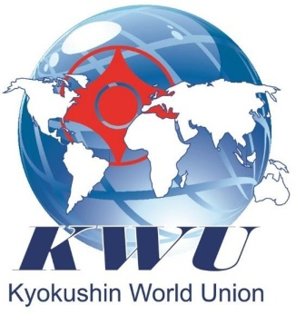
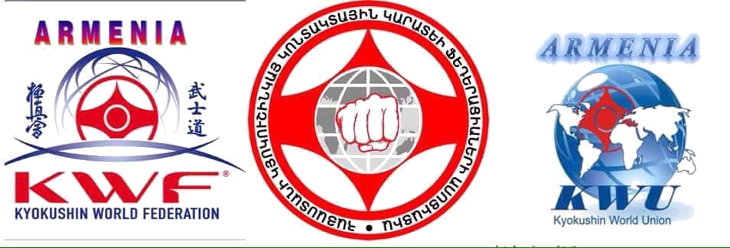

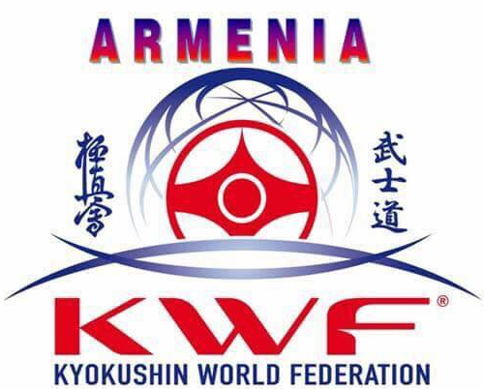

The 2nd Armenian international open championship of Kyokushinkai, among young men and women, juniors and junior girls (kumite)
Yerevan, 24-26 of April 2020

Provision

24-26 of April 2020 Yerevan

The second Armenian international open championship of Kyokushinkai, among young men and women, juniors and junior girls (kumite)

Date: 24-26 of April 2020

Conditions for admission to the championship:
Conditions for admission to the championship: The allowance representatives of national federations inviting all interested groups of kyokushin , that accept the rules of Kyokushinkai at the age of 12-17 with the style qualification not less than 8 kyu.

Championship sponsors:
KWF Armenian Federation and The Armenian Association of Kyokushin Karate Federations.

The schedule of events:

Date | Time | Event | Participants
April 24 | 09:00-19:00 | Mandate commission  /scheduled/ | Members of teams,  fighters
April 24 | 14:00-16:00 | Judicial seminar | Judges
April 24 | 18:00-19:00 | General meeting | Leaders, members of teams,  Trainers , Judges
April 25 | Day off | Day off | Day off
April 26 | 10:00 | Grand opening | Everyone
April 26 | 10:30-16:00 | Preliminary fights | Everyone
April 26 | 16:00-19:30 | Final fights | Everyone
April 26 | 20:00 | Award ceremony | Everyone

Financial Conditions
Starting fee 20 €.

Applications for participation:
Submission term of preliminary applications (application № 1): till 24 of March 2020
ATTENTION!!! Together with preliminary application there must be provided the following documents:
- Photo with dogi (portrait photo in electronic form, format jpeg, license not less than 300 dpi)
- application№ 3 – filed for each fighter

Submission term of final applications – till 10 of April 2020 (Attention! Without submission of preliminary applications- finals are not accepted). The final application must be sent by email, it must contain all the required signatures and stamps.

Applications are accepted only with the established form (application № 1). Application must be signed by the presidents of national federations of the country, which fighters are accorded in application.

Applications are accepted by the address:
e-mail: ds.club@mail.ru
Contact number:
+37499 33 64 62 Martirosyan Armine (English language), (Russian language)
(additional services - hotel reservation, transfer)

Original application with all the required documents is given to the team representatives to the mandate commission.

Competition Rules:
Competitions are hold according to KWU rules, which are posted on the official site – http://www.kwunion.com/documents/

Awards:

Conditions of summing-up
Kumite sport competitions are hold according to the elimination system after one defeat. In each weight category the two third places are played out (fights for the 3rd place are not held)

Awarding of winners and awardees

Winners and awardees of competitions (1-3 place) are awarded with medals and diplomas, as well as with cups of corresponding degrees.

Holding place:

Sports arena: SPORTS COMPLEX <<MIKA>>

Location: Armenia, Yerevan
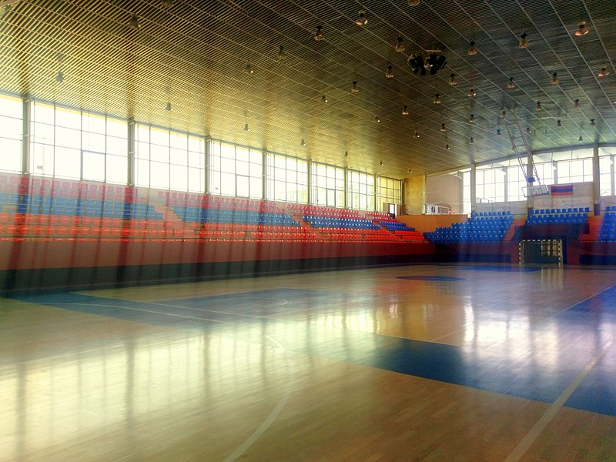 Spaciousness: 7000 places
Address: Manandian st., 41 (Shengavitadm. region)

Weight categories and composition of teams

Team’s composition:
- official trainer of the team;
participants-up to 3 people from country in each weight category;

№ | Age category  (discipline) | Weight category
1 | boys(12 -13 full years, kumite) | 35, 40, 45, 50, 55, 55+
2 | girls (12 -13 full years, kumite) | 40, 45, 50, 50+
3 | boys (14-15 full years, kumite) | 45, 50, 55, 60, 65, 65+
4 | girls (14-15 full years, kumite) | 45, 50, 55, 60, 60 +
5 | boys (16-17 full years, kumite) | 55, 60, 65, 70, 75,75+
6 | girls (16-17 full years, kumite) | 50, 55, 60, 65, 65+

The age of the fighter is determine don't heyday of passing the Mandate commission, i.e. on 24 of April 2020.

Sponsors reserve the unite the weight categories.

Requirements for the fighters of competitions.

On Mandate commission the head of the team affords the original application, each fighter must have the following documents:
  - passport or birth certificate (for under age participants)
  - Permission of sports doctor for participating in competitions (in English);
  - Written permission for participating from both parent ap.№2;
  - Insurance contract from accidents(original, in English)

Security:
Each fighter, admitted to competition must have:
- White dogi and belt, corresponding to the fighter’s qualification;
- An individual shell on the groin for boys and juniors is mandatory, for girls and juniors at will;
- Protectors for shins and upper foot;
- Knee Pads, shoulder pads-at will;
- Pads for hands-necessarily for both sexes of participants;
- helmet - required for participants of both sexes;
- breastplate of set sample-for women and junior girls necessarily;
- mouth guard (protector of oral cavity), white colour – at will. If there are braces on teeth, the mouth guard is necessary.

All the participants will have the opportunity of getting remedy before the mandate commission.

ATTENTION! All the remedies are strictly individual!

Antidoping security:

- All the sportsmen can undergo doping-control, according to the standards of Worldwide anti doping association (WADA).
- All the sportsmen must follow the rules of anti doping codex WADA. In case of offence by the sportsmen of anti doping codex WADA, refusal or absence of sportsman for passing the doping-test, there will be applied sanctions to them, according to the standards of anti doping codex WADA(till complete disqualification of the sportsman).

Schedule of fights:

Age category «boys / girls» (12-13 years)
Boys (12-13 years)
Preliminary fights:2 min + 1 min
Semi-final and final fights: 2 min + 1 min + weighing (weight difference 2,5 and more kg) +1 min

Girl (12-13 years)
Preliminary fights:2 min + 1 min
Semi-final and final fights: 2 min + 1 min + weighing (weight difference 2,5 and more kg) +1 min

Age category «boys / girls» (14-15 years)
Boys (14-15 years)
Preliminary fights: 2 min + 2 min
Semi-final and final fights: 2 min + 2 min + weighing (weight difference 2,5 and more kg) + 2 min.

Girl (14-15 years)
Preliminary fights: 2 min + 2 min
Semi-final and final fights: 2 min + 2 min + weighing (weight difference 2,5 and more kg) + 2 min.

Age category «boys / girls» (16-17 years)
Boys (16-17 years)
Preliminary fights: 2 min + 2 min

Semi-final and final fights: 2 min + 2 min + weighing (weight difference 2,5 and more kg) + 2 min.

Girl (16-17 years)
Preliminary fights: 2 min + 2 min
Semi-final and final fights: 2 min + 2 min + weighing (weight difference 2,5and more kg) + 2 min.

№ 1 – Application form
Declaration
For participation on the second Armenian international open championship of Kyokushinkai,
Among young men and women, junior and junior girls (kumite)
Yerevan, 24-26 of April 2020

from
(the name of the country and team)

№ | Surname, Name (in English) | Date of birth (full)  dd/mm/yy | Age | Gender  male/ female | Rank  Kyu/Dan | Exact  weight (kg) | Coach | Country | International Organization

Full names of the representative of team

Contact number of the representative of team

Signature and stamp of the president of International Federation and club / М.П.

ATTENTION! It must be attached photos to the declaration of each fighter-PHOTO in dogi (portrait photo in electronic form, format jpeg, in high quality).

12

№ 2 – from parents

DECLARATION

We, ……………………………………………………………………………………

(full names, telephone number, ID/PIN number and exact address on ID card), as legal representatives of………………(full names, PIN/ID telephone number) WE DECLARETHAT,

We would like our child to be allowed to participate in category................in……………2nd Armenian open international championship (kumite) in weight categories, which will be held on April 24-26, 2020 in Erevan, Armenia, Mandalyan 41.
We give a clear approval that our child will participate in this tournament, in order to strengthen health, increase physical and sports culture.
In addition, we confirm that we are familiar with safety rules during the competitions and that our child will res pect them and that he/she has received all the necessary instructions.
We declare that our child is healthy, well prepared and there are no obstacles for his/her participation the competition.
We are aware that in case of injuries the adverse circumstances and consequences during and after 1st Armenian open international championship, we will bear the cost of our child’s treatment and recovery, without having claims against the organizers of the competition, judges, coaches, trainers and other officials and NPO “Armenian KWF Federation”.
This declaration, we issue with clear conscious and without foreign interference, fully understanding that Kyokushin Karate is a contact sport with direct fighting and it is absolutely possible for our child to receive injures and adverse consequences of them during participation in the competition.
We confirm that our child does not use prohibited drugs and we give our agreement, if necessary, for a doping sample to be taken and medical check to be done.

- DECLARANT:

- DECLARANT:

Attachment N 3

This attachment shall be filled-in by fighters and sent to the e-mail
together with a preliminary

Full name
Photo is obligatory | The picture in karategi (portrait digital photo, jpeg format, high resolution) – to attach (as a separate file) to the application
Date of birth
Country
International Organisation
Qualification (kyu, dan)
Weight
Height
Sports results

