Guidelines for participants.
4th KWU Kyokushin World Championship
among men and women in weight categories
December 7-8, 2019, Kazakhstan, Nur-Sultan

“TIME TO BE UNITED!”

Information for coaches, medics and supporters

The above stated categories of the World Championship’s participants pay all their expenses on their own.
The applications for hotel booking, visa support and buying of the tickets to the arena you should send to the e-mail - champ@kwu2019.com with a phrase ‘Team of (your country)’ in the subject line, only after registration on the official website.

Deadline: not later than 01.11.2019.

Officials

The World Championship’s participants of this category pay all their expenses on their own.

In order to be registered as an official a candidate should send a request to the e-mail -champ@kwu2019.com with a phrase ‘Officials’ in the subject line and provide the following information:
- Name and surname
- Date of birth
- Job position
- Status in Kyokushin

Your application will be considered and after that you will receive a reply. The status of "Officials" is confirmed only after receiving confirmation from the official e-mail of the World Championship.
Attention! Registration of officials on the website is not provided. If you have registered on the website as a supporter and sent a request to the e-mail champ@kwu2019.com, but did not receive confirmation, you will be able to attend the World Championship only as a supporter, without being provided with a badge.

Judges

The official judges are selected on the side of KWU among the KWU accredited judges. The list of the approved judges is published on the official website of the World Championship – www.kwu2019.com.
Candidates for judging can take part in the judging seminar, which will be held on December 4-6, 2019 in Nur-Sultan. To do this they should send a request to the e-mail champ@kwu2019.com with a phrase ‘Candidates for judging’ in the subject line. All financial expenses they pay on their own.

The Supreme Judge of the World Championship is Yuri Trutnev, 6th Dan, Russia.
The Deputy Supreme Judge of the World Championship is Ramil Gabbasov, 5th Dan, Russia.

Visa support

In order to get visa support from KWU you should complete the following steps:
1) To register competitors, coaches, medics and supporters on the official website of the championship.
2) To send the request to the official e-mail of the World Championship – champ@kwu2019.com with a list of candidates for judging (with a phrase «Candidates for judging»), and a list of the Officials (with a phrase «Officials» in the subject line). Please attach to this email their passport copies (a page with photo) in a good quality.
3) To book a Hotel for supporters, candidates for judging, officials, coaches and medics by sending a request to the official e-mail of the World Championship.
4) To send to the e-mail - champ@kwu2019.com a request for visa support with a phrase «Visas for (your country) ».

Please see the order of enter and stay of foreigners in the Republic of Kazakhstan in Annex 1. Find your country in the list and check whether you need visa.

Recommendations concerning flights

All categories of the World Championship’s participants cover the cost of their flight to Nur-Sultan and back on their own.
The Organizing Committee highly recommends buying a unified ticket from the city, where you live to Kazakhstan since it can:
- significantly lower the risk of a late arrival,
- significantly reduce your expenses.

Accommodation
The accredited hotels of the 4th KWU Kyokushin World Championship:
“Radisson Hotel, Astana” (Kazakhstan, Nur-Sultan, Saryarka Avenue 4)
“Park Inn by Radisson Astana” (Kazakhstan, Nur-Sultan, Saryarka Avenue 8).



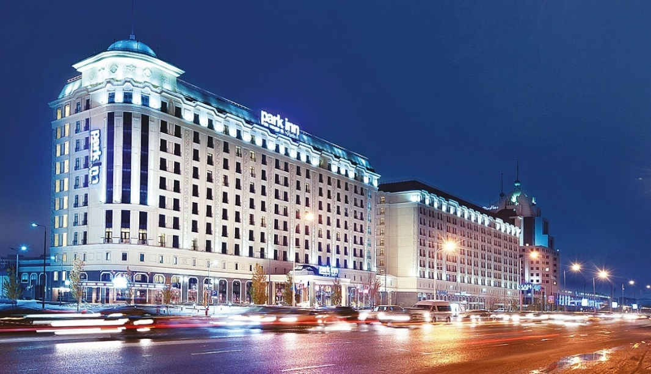

The official hotel for judges is “Astana Marriott Hotel” (Kazakhstan, Nur-Sultan, Dostyk Street 2)

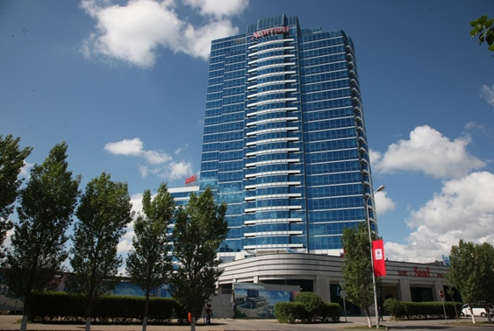

Hotel booking should be made only by sending a request to the e-mail - champ@kwu2019.com with a phrase «Hotels» in the subject line not later than 01.11.2019.
For registered competitors and approved official judges KWU will book the hotel rooms on its own. There is no need to send a request for booking for these categories of participants.

Venue
Martial Arts Palace “Jekpe-jek”
41 Kabanbai batyr avenue, Esil district, Nur-Sultan, Kazakhstan.

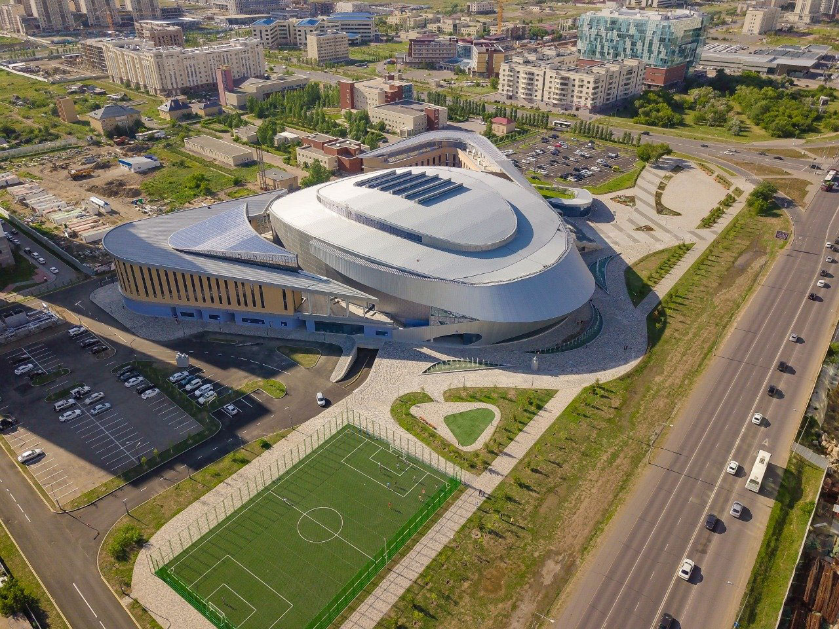
Entrance to the arena

The competitors will be able to access the warm-up area by presenting their badges.
On the second day of the competition those who will not get through to the finals will be offered special spectators’ seats, which they can attend with their badges.

Officials, who will be approved by KWU, will get the badges, which will allow them to take seats in the special spectators’ sector. (this option is available only when the official status is confirmed by email champ@kwu2019.com. )

Coaches and medics on December, 7th will be admitted to the warm-up area with their badges presented.
On December, 8th coaches and medics will be admitted to the warm-up area only if the competitor, whom they accompany, fights in the final bouts of the World Championship.
While registering on the website, a coach is required to specify names of the competitors whom he or she will accompany to the tatami. A competitor can be accompanied to the tatami by only one coach, the one who specified the name of this particular competitor in the registration form. Moreover, the names of competitors specified in the registration form will be written on coaches’ badges.

Supporters should buy tickets to the arena by sending a request to the e-mail -champ@kwu2019.com with a phrase «Ticket to the arena» in the subject line.

Official information:

Weight categories

Men (18 years and older, kumite): 60, 65, 70, 75, 80, 85, 90, 95, 95+ kg.
Women (18 years and older, kumite): 50, 55, 60, 65, 70, 70+ kg.

The competitor’s age is determined as at the day of going through the credentials committee, which is December 6, 2019.

Conditions of participation and number of competitors from each country

One competitor from a country is allowed in each weight category. The host country of the KWU World Championship – Kazakhstan is allowed to apply two competitors in each weight category.

Representatives of national federations, who have passed national qualifying tournaments with calling of all interested groups of Kyokushin in a particular country at age of 18 years old and above with a style qualification not less than 4th kyu are allowed to participate in the World Championship.

Time and place of holding national qualifying tournaments are determined jointly by representatives of international organizations, listed in the “Members” section on www.kwunion.com.

Participation of competitors from WKO Shinkyokushinkai

The competitors from WKO Shinkyokushinkai, who wish to participate in the 4th KWU Kyokushin World Championship, should contact their Branch Chiefs, who would inform about this request the WKO Shinkyokushinkai Headquarters.

General rules
The competitions will be held by the rules of KWU, which are published on the official website: www.kwunion.com

Conditions of summarizing of the results
The championship is a single-elimination tournament with elimination of the loosing fighter after one defeat. There will be two 3rd place winners in each weight category (no bouts for the third place).

Prize funds:
The winners from the 1st place to the 3rd place will be awarded with the prize fund of the World Championship:
1st place – 3000 $
2nd place – 1500 $
Two 3rd places – 750 $ each

Timeline of events

03.12.2019 (Tuesday)  Arrival of judges  04.12.2019 (Wednesday)  14:00 – 20:00 – Judging seminar  05.12.2019 (Thursday)  Arrival of competitors, officials, coaches and country representatives  10:00 – 14:00 – Judging seminar  06.12.2019 (Friday)  09:00 – 17:00 – Credentials Committee  10:00 – 14:00 – Judging seminar  18:00 – 19:00 – Common meeting of competitors, judges, organizers and representatives | 07.12.2019 (Saturday)  10:00 - Preliminary fights (up to finals)  08.12.2019 (Sunday)  16:00 – Opening ceremony  16:30 – finals  21:00 – Sayonara Party  09.12.2019 (Monday)  Check out from the hotel (before 12 am) and departure

Financial conditions

The entry fee from competitors will not be charged.

KWU covers the following charges:
- accommodation for the approved KWU judges in twin rooms of the accredited hotel (Full Board) – December, 3 – 9;
- accommodation for competitors in twin rooms of the accredited hotel (Half Board) – December, 5 – 9;
- lunches for competitors during the days of the tournament – December 7-8.
- transfer for competitors and the approved KWU judges from the airport Nur-Sultan to the hotel and from the hotel to the airport Nur-Sultan.

Anti-doping control

The prize-winners from the 1st to the 3rd places will have to go through the doping test in accordance with the rules of the World Anti-Doping Agency (WADA). General amount of the samples, which will be taken – 60.

Organizing committee – champ@kwu2019.com, +7-495-640-23-63

Annex 1.
