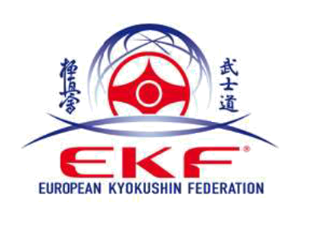

33^{rd.}European Kyokushin Championships 2019.

Porto, June 21, 2019

OFFICIAL INVITATION

Dear Country Representative.

The Portuguese Kyokushin Federation in cooperation with the European
Kyokushin Federation and Kyokushin World Federation has the honor to invite your National Team to participate at the 33rd. European Kyokushin Championship.

The competition will be at Weight categories kumite for men, women, children and juniors.
Kata for adults, children and juniors.

The event will take place in Vila do Conde (Oporto Portugal) at October 24-27th 2019. In Sports Pavillion of Vila do Conde.

If you need a visa please start the procedure to arrange this immediately
You will find detailed information concerning the event in Bulletin no.1.

We count on your support to secure this event as a real success and we wish you and your team a great time in Portugal.

I am looking forward to see you in Portugal.

Sincerely Yours,

Antonio Pereira

