33rd European Kyokushin Championship
October 24 - 27 2019

Bulletin No. 1

1. INTRODUCTION

The Portuguese Kyokushin Federation in cooperation with the European Kyokushin Federation and the Kyokushin World Federation have the pleasure to invite you to the :

33rd European Kyokushin Championship in the city of Vila do Conde, (Oporto Portugal.)

The event will take place at the Sports Pavillion of Vila do Conde.

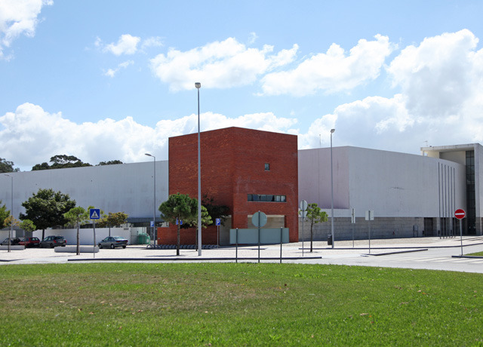

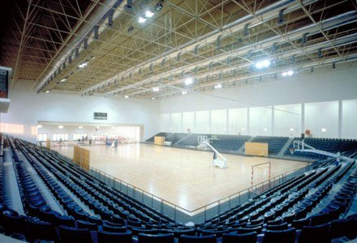

2. OFFICIAL HOTEL( only for participants and officials)

Santana Hotel
Address: Monte Santana, n.º 188
Azurara VCD Portugal
https://www.santanahotel.pt/

Numbers category | accommodation | Accommodation per night
Triple-bed | Triple | 147 Euro/ Night – for 3 persons
Double - bed | Double | 120 Euro/ Night – for 2 persons
Twin- beds | Double | 110 Euro/ Night – for 2 persons

Price for 1 Room: Breakfast, Pool, Spa and Gym included.

Hotel booking.

All hotel booking information should be send to Organizer: eck2019viladoconde@kyokushinkai.pt

There is only 52 Rooms in the Official hotel, so you need to send us your booking information as soon as possible.
Information about additional hotels will be available soon, with different prices.

Travel.

From Oporto Airport you can travel to Vila do Conde directly by metro or bus and the time travel is about 15 minutes away.

You have to arrive at the hotel Thursday 24th of October before 20.00.

3. COMPETITION CATEGORIES
The Championship will take place in kumite and kata divided into categories of women and men. In the annex you will find applications forms and as well all the different kumite and kata categories.

3.1 PLEASE LOOK AT ANNEX KUMITE RULES AND KATA RULES.
3.2 OBLIGATORY PROTECTIONS: Please look at annex Rules for Kumite.
3.3 DURATION OF THE MATCHES.
Please look at annex: Rules for Children or Adults.
3.4 KATAS to be done.
Please look at annex. Rules for Kata.
Attention:
Detailed KWF rules regarding Kumite and Kata can be found in 3 attachments: International Championship Officials, Rules of Kyokushin Kata Competition and Categories Children and Juniors.
Judging Team under supervision of Main Judge Antonio Pinero and General Secretary Andre Drewniak will conduct an open draw on October 25th. after 20.00 with participation of the Technical Judge Fernando Perez and the Computer specialist Robert Wajgelt.

3.5. KUMITE RULES
IMPORTANT NOTICE:

KWF HAS INTRODUCE THE NEW CATEGORIES FOR WOMEN AND MEN 18-21 year

PLEASE REFER TO ANNEX KUMITE RULES FOR CHILDREN AND ADULTS.

3.6 PROTECTORS
Below are shown the athletic supporters (protectors) required during the Championship, approved by the EKF/KWF.

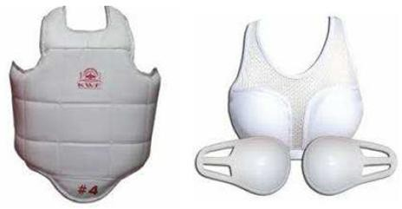

EKF MAY PERMIT other types of athletic supporters with other logo types only if they have the same level of protection and keeps similar aesthetic to the ones homologated by EKF/KWF, and they have to be approved by the Main Judge of the Championships.

3.7. DURATION OF THE MATCHES

PLEASE LOOK AT ANNEX KUMITE RULES FOR ADULTS AND CHILDREN.

If there are too many participants at the Championship, and preliminary matches have to be done with obligatory decision, it will be communicated before the Championship start.

3.8. KATAS TO BE PERFORMED.

PLEASE REFER TO ANNEX KATA RULES.

The competition will be divided into two rounds.
Four competitors of each k a t a category with the highest scores will pass to the Finals.

4. GENERAL RULES

Observe carefully and select the correct weight-categories. The Judging Team can expel participants if their weight is not the same as stated in the Registration Form.

The Judging Team can modify categories if there are not enough participants.
Important: Every participant must identify him/herself with Passport or ID-card. KWF MEMBERS MUST HAVE THE OFFICIAL KWF PASSPORT.

Only official Registration Forms undersigned by Country Representative will be accepted.
Deadline is 15th of September 2019. After this date we accept no more inscriptions.

5. REGISTRACTION

Send your Registration Form t o t h e G e n e r a l S e c r e t a r y a n d t o t h e Organizer.
Email addresses are.
general.secretary@europeankyokushin.org
eck2019viladoconde@kyokushinkai.pt
The weight in and the checking will be done Thursday 24th of October 2019 at the Official Hotel.
All the competitors, referees and officials must come together at the same time as a group and country.
The country representative pays for all his/ hers competitors at the same time to the EKF treasurer.

6. VERIFICATION
This verification will be followed by members of the Judging Team from the European Kyokushin Federation.

Participation fee per fighter is 45 €. This has to be paid together with the registrations at the hotel to EKF Treasurer Shihan Lars Hogquist.
The competitor who will participate in kumite and kata - has to pay 90€.

On the weight-check- in you must be prepared to give the following documents:
    - Parents Agreement (only for competitors under 18 years old).
    - Fighter Waiver Form (you have to fill in and sign the document during the weigh in).
    - ID or Passport (to check the nationality and age).
    - Doctors certificate (only for kumite competitors).
    - Must pay the participation fee.
    - Each competitor must have a personal insurance for any accident that may occur at the competitions.
    - All the KWF members must present their KWF passport if not must buy a new one.
    - Participants from KWF countries without yearly Affiliation payment will not be accepted.

7. REFEREE COURSE

The Judging Course and Coaches Meeting will take place in a designated hotel. The time and place will be announced later.

Registration is free, except for those who want to obtain the title of International Judge or International Referee given by the European Kyokushin Federation (EKF) and guaranteed by Kyokushin World Federation (KWF). The fee and requirements are:

    - International Judge: 50 € (must be minimum 1st dan and National referee).
    - International Referee: 75 € (must be minimum 2nd dan and International Judge).

8. SAYONARA PARTY
On Saturday night, there will be a Sayonara Party for everyone. We hope that you will join the party.
The cost is 25 euro per person. You purchase tickets on Thursday during registration.

9. ADDITIONAL INFORMATION
More information will be provided in Bulletin No. 2.

We wish you a pleasant stay in Vila do Conde.
Osu.

Portugal Kyokushin Federation
President
Shihan Antonio Pereira

