Norway: Candidates for dan-grades preparing for summer-exam

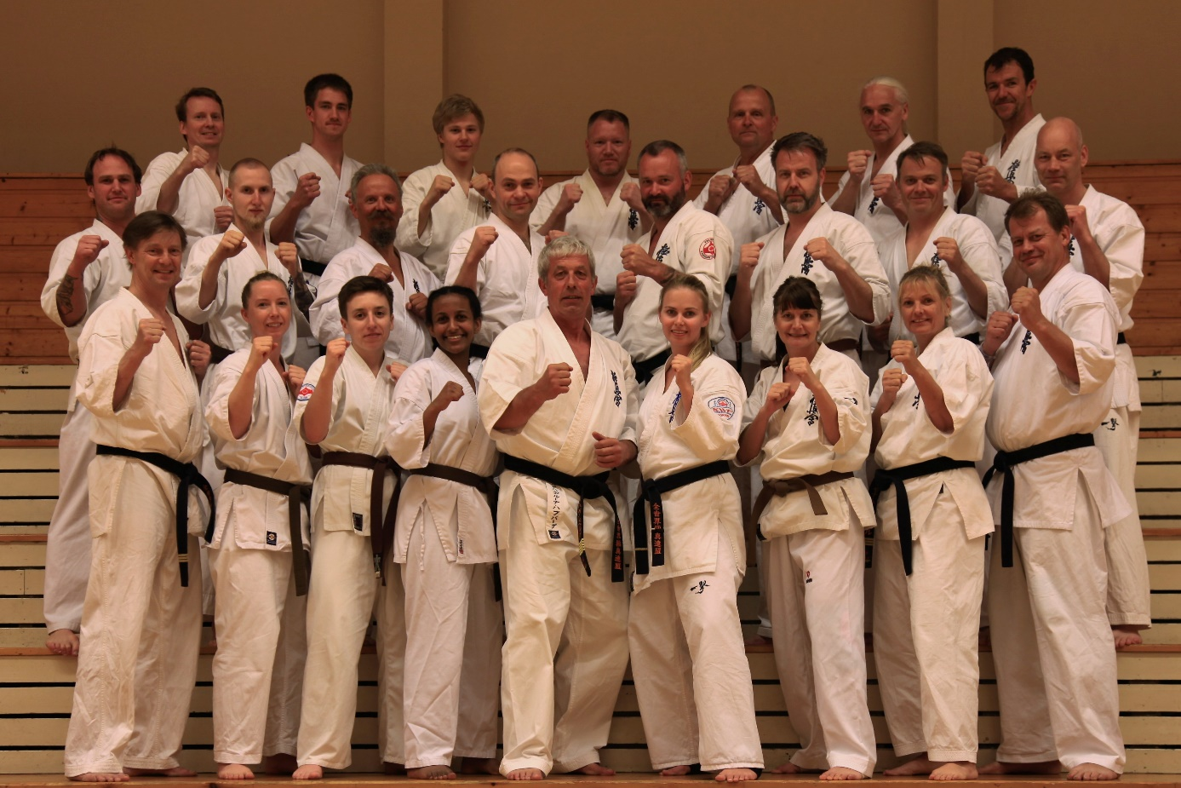

The yearly Norwegian Kyokushin Summer Camp always ends with the Dan examination, and this is the highlight for many practitioners of Kyokushin in Norway. More than 20 candidates are preparing for the exam this year, from shodan to yondan. The Norwegian Kyokushin Organisation Norway (NKKO) usually arranges a preparation seminar for the candidates, and late April a weekend seminar was held at Lørenskog, close to Oslo. The host was Lørenskog Karate Klubb, and NKKO sent Shihan Geir Havreberg as the head instructor. Due to the pilot-strike in SAS and cancelled flights, Shihan Tom Sølve Erga and Shihan Jarle Sundvor could not attend, but Sensei Gorm Øian and Sensei Mona Kirkenær from Lørenskog Karate Klubb stepped up as stand-ins.

Shihan Geir Havreberg trained basic techniques and katas, and how to improve stances and the understanding of the movements. In addition, the students were drilled in their katas. All together, the 20 candidates and some future candidates had 5 classes from Friday to Sunday.

- The candidates have general a high level and most of them are well prepared. However, the examination is tough and demanding and I have given all of them something to work on to pass the exam, says Shihan Geir Havreberg.

