REQUIREMENTS TO THE EQUIPMENT OF PARTICIPANTS OF THE YOUTH KWU KYOKUSHIN EUROPEAN CHAMPIONSHIP, BERLIN 2019

Each fighter, allowed to participate in the competitions, must have individual protective equipment.
Protective equipment must be of white colour and in good condition (clean, intact, without scuffs). The size of protective equipment must reliably protect the impacting surface of fists and shins.

- Protectors for shin and insteps of stocking type
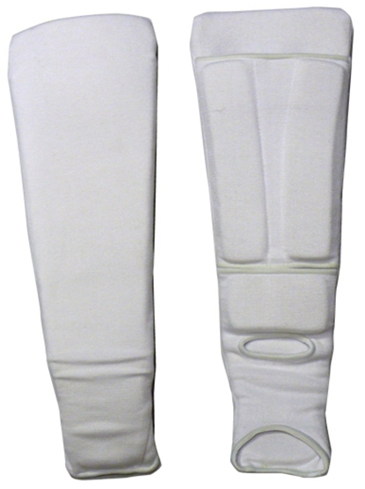 | 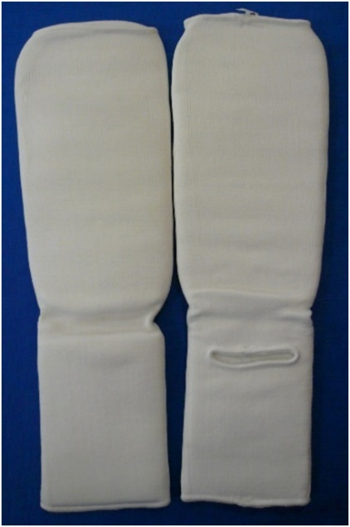
The usage of protectors for shin and insteps as elastic stockings of white colour with compressor (thickness of at least 1 cm) is permitted. The usage of plastic flaps and insets is forbidden.

- Protective gloves with an obligatory protection of joints 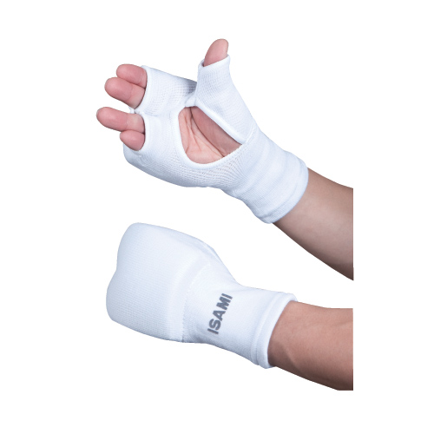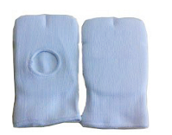

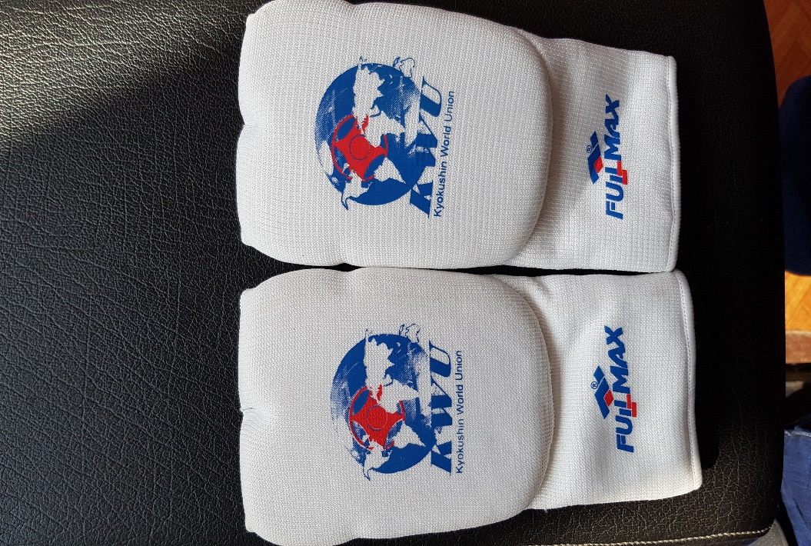 | 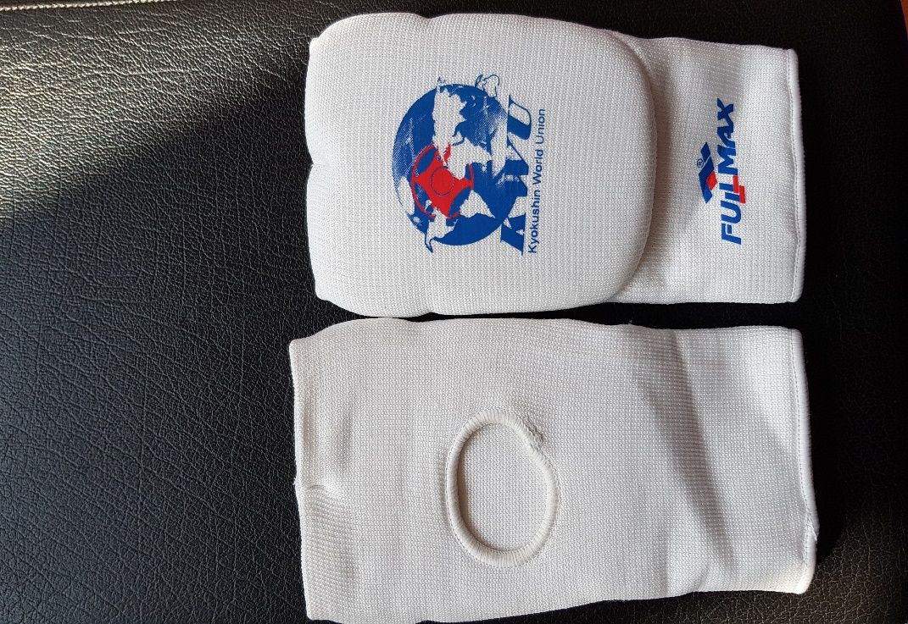

The thickness of compressor must be at least 1 cm. The usage of plastic flaps is forbidden.

- Protective helmet with obligatory protection of chin

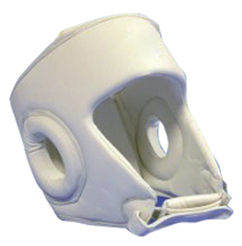 | 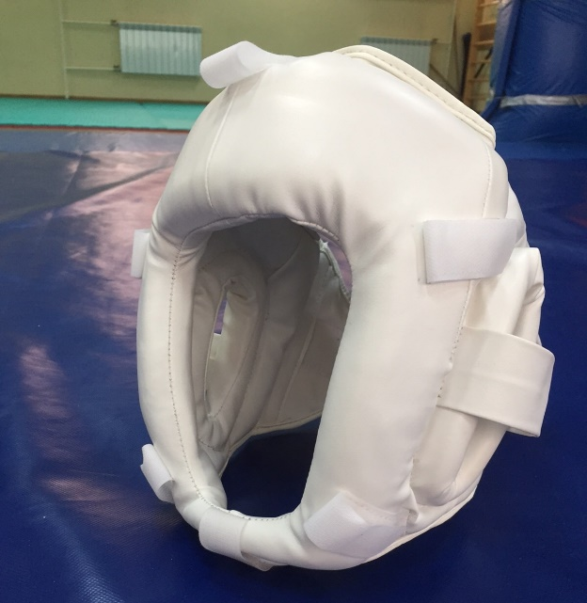
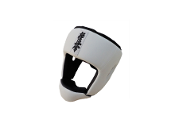 | 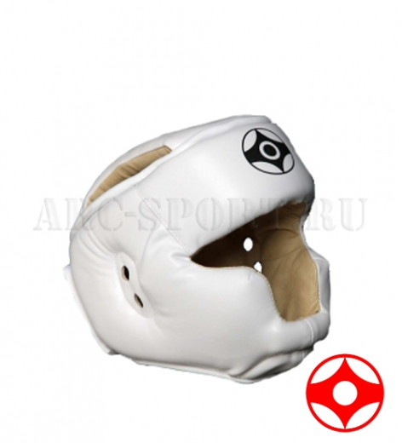

- Chest protector – girls, girls juniors
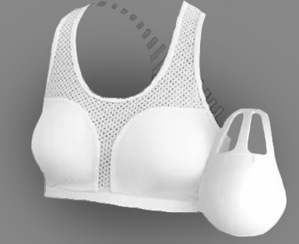

The participants are allowed to use chest protector of the following model: the upper bound of protector – not above the second rib level, the lower bound of protector – not below the edge of costal arches, the lateral bounds – along the anterior axillary lines. It must protect chest. CHEST PROTECTOR MUST BE WITHOUT PLASTIC AND MUST COVER ONLY CHEST.
The usage of hard plastic chest protectors is forbidden.

- Individual groin shell – boys and juniors
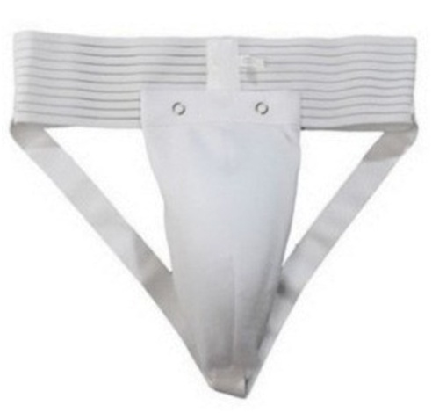 | 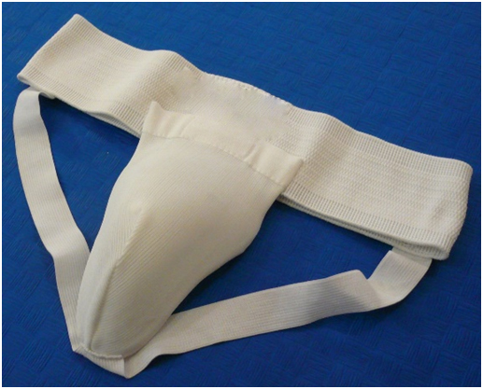
Groin protectors for girls, girls juniors – voluntary.

- Gumshield (oral cavity protector) – voluntary, unless a sportsman has braces on his/her teeth.

ATTENTION! Each sportsman must have his/her own protective equipment.

In case of non-compliance with any of these rules, a sportsman is not allowed to compete.

If during a bout it turns out that the size of protective equipment does not fit a sportsman, the bout will be stopped and he/she will be disqualified from the tournament.

ATTENTION! ALL THE PROTECTIVE EQUIPMENT MUST BE PRESENTED TO THE CREDENTIALS COMMITTEE!

