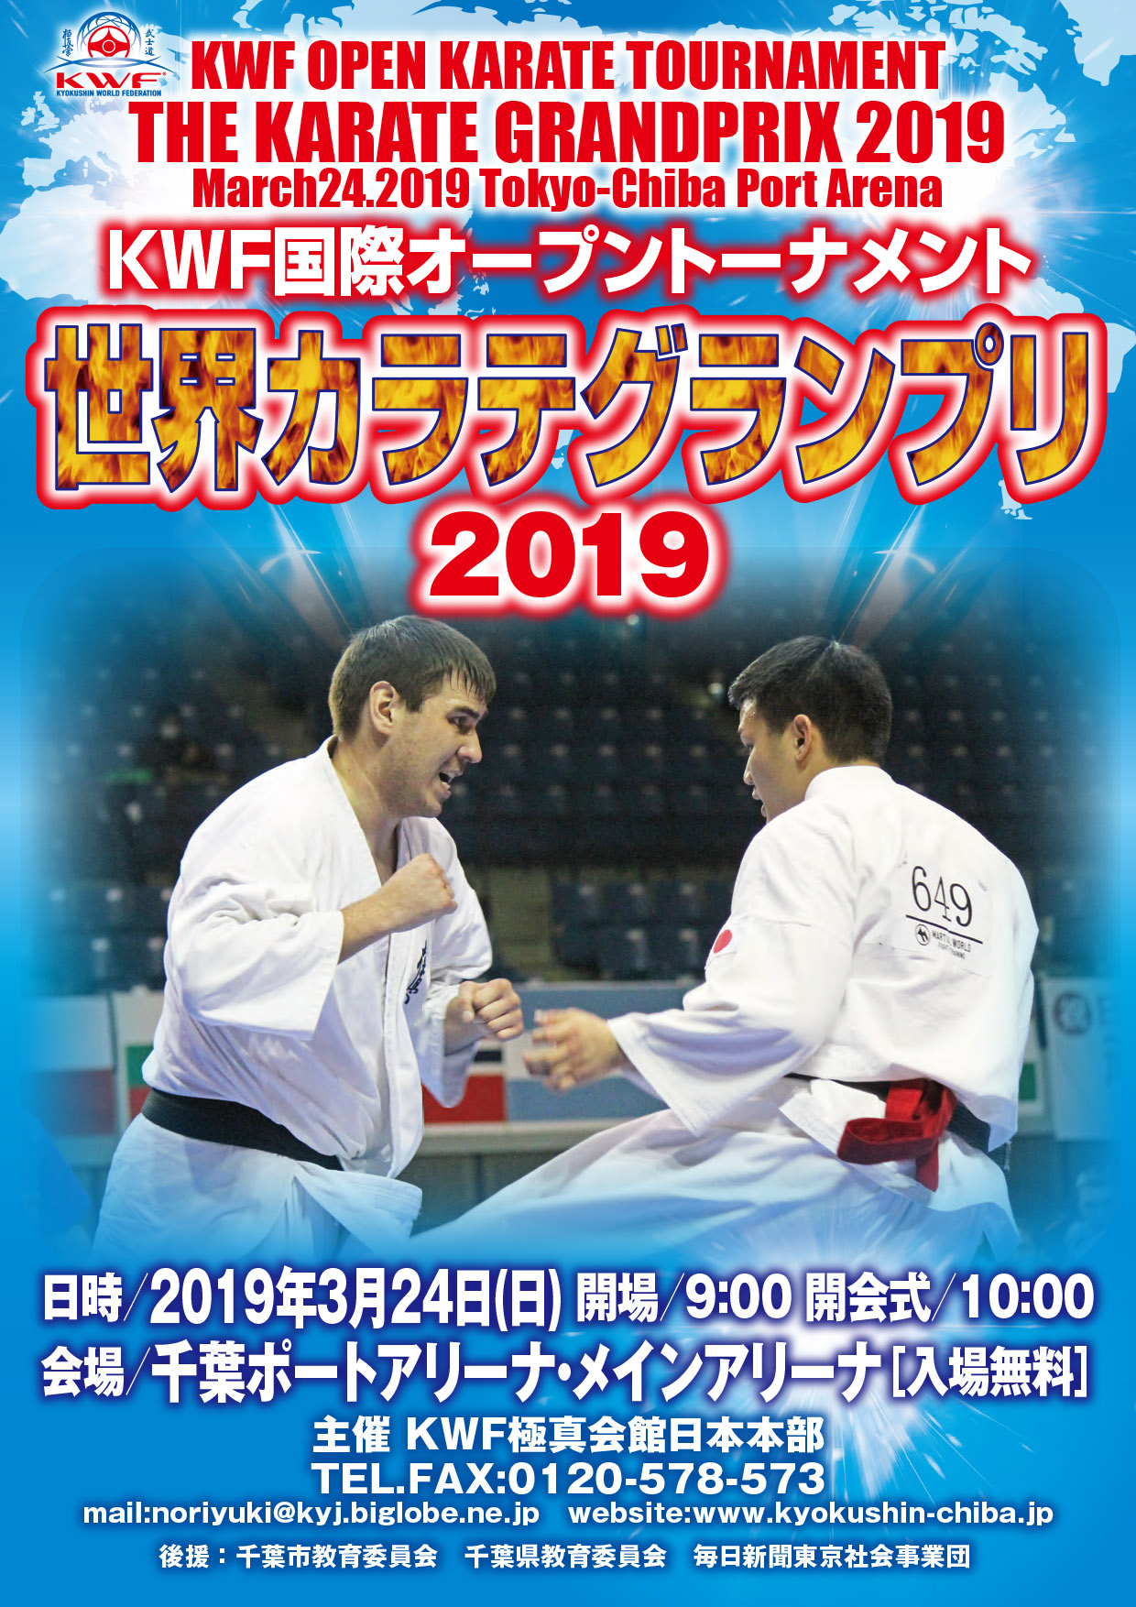

【Invitation Letter】
あああ
あああ
ああ
あああ
あああ

THE KARATE GRANDPRIX 2019

The 6th KWF Open Karate Tournament

Nov, 2018
Dear Country and Team Representative
KWF JAPAN has the honor to invite you and your team to participate in THE KARATE GRANDPRIX 2019 on March 24, 2019 in Chiba-Tokyo, Japan.
We will hold this Open Karate Tournament under the official auspices of the Chiba City Board of Education, Chiba Prefectural Board of Education and the Mainichi Newspaper.
We would highly appreciate your co-operation and participation.
We would welcome many competitors to join. The number of participants in each class is unlimited.
Very sincerely yours,
OSU


Shihan Noriyuki Tanaka
Representative of K WF JAPAN

DATE
March 24, 2019

COMPETITION VENUE :
Chiba Port Arena (refer to page 5 “COMPETITION VENUE”)

SCHEDULE :
9:30 a.m. Referee/Judge Meeting
10:00 a.m. Opening Ceremony
10:10 a.m. Competition Begins

REGISTRATION AND WEIGHT-IN :
13:00 March 23
Lobby of APA Hotel & Resort Tokyo Bay Makuhari
(refer to page 6 “ACCOMODATIONS” ), 1F West wing

REGISTRATION FEE :
7,000 JPY : (No. 1 – No.39)
8,000 JPY : (No.40 – No.50)
Required fee in cash at the REGISTRATION AND WEIGHT-IN (March 23)

PRE-REGISTRATION DEADLINE:
January 31, 2019 ( If you need VISA , January 15, 2019 )
Only accept mails from the dojo representative.

GENERAL RULES:
K WF Rules for all Categories.
Notice: Jodan-Mawashi-Geri and Gedan-Mawashi-Geri are allowed for the category of Boys and Girls except Jodan-Hiza-Geri.
Rules are the subject to change appropriately.

JUDGES:
Selected by the KWF JAPAN
Please participate in this Open Tournament as
JUDGE from your country too.

AWARDS:
Trophy or Medal for top three
Two competitors for third place (No game for the third place)

LIABILITY:
Participate on your risk.
Required Parental Permission Signature for the under 18.

COMPETITION VENUE:
Chiba P ort Arena
http://chibacity.spo-sin.or.jp/shisetu/arena-top/arena-main.html
1-20 Tonya-cho, Chuo-Ku, Chiba City
Tel: +81 43 241 0006
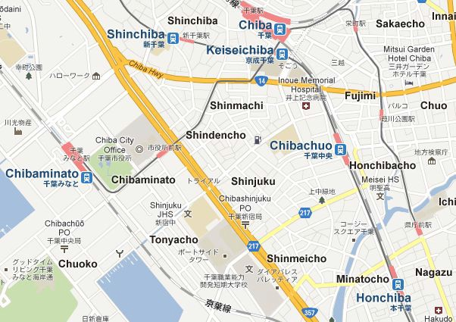

Chiba Port Arena
~8minutes by train to JR Chiba Minato Station (Chiba Port Arena)
from JR Kaihin-Makuhari Station (APA Hotel).
~15 minutes by walk from JR Chiba Minato Station.

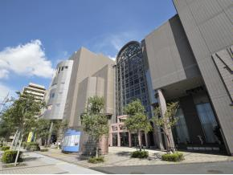

ACCOMONDATIONS: Official Hotel of 【KARATE GRANDPRIX 2019】
APA Hotel & Resort Tokyo Bay Makuhari
http://www.apahotel.com/makuhari/english/guest.html
2-3 Hibino, Mihama-Ku, Chiba-city, Chiba, Japan
Tel: + 81 43 296 1111 e-mail ah-rmk@apa.co.jp

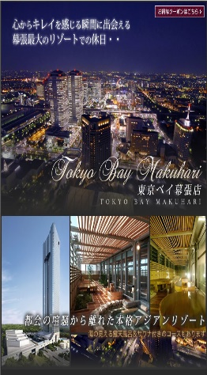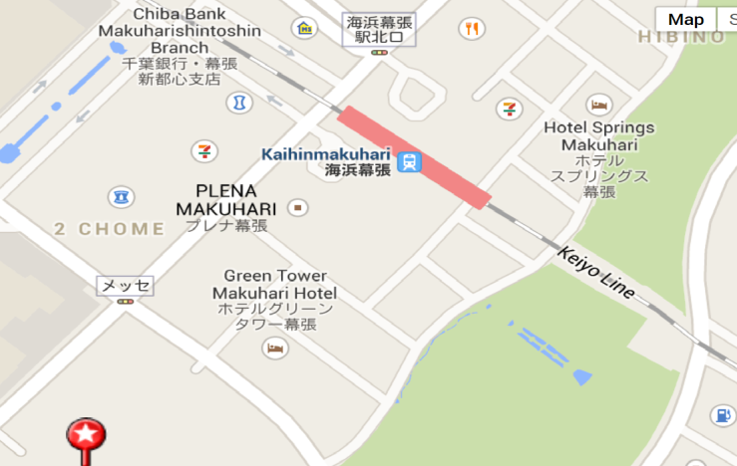

APA Hotel & Resort Tokyo Bay Makuhari
(8 minutes by walk from Kaihin Makuhari Station.)
One building truly stands out among the Tokyo Bay Area`s modern skyline. There are some restaurants at this hotel.

IMPORTANT – the official hotel “APA Hotel” Reservation
- KWF Japan would not reserve the hotel. Please reserve [APA Hotel & Resort Tokyo Bay Makuhari] on your own responsibility through “Booking.com” http://www.booking.com/.

- Recommend you to reserve the amount of rooms ASAP since rooms are limited. Cancellation would be accepted until just before the lodging.

- Recommend you to reserve the Hotel during the November since VISA documents require the Hotel information ( Hotel Name, TEL, Reserved Date ) .

- If the APA hotel was unavailable, recommend you to reserve the others nearby the APA hotel through “Booking.com” http://www.booking.com/ on your own responsibility.

  - Other Recommended Hotels
    - Hotel New Otani Makuhari (0.1km from APA Hotel)
    - Hotel Francs (0.3km from APA Hotel)
    - Hotel Green Tower (0.3km from APA Hotel)

- Tutorial for “Booking.com”
  - Visit “Booking.com” http://www.booking.com/
  - Select language
  - Enter the Destination or hotel name, please enter “Chiba”
  - Enter “check in date”, “check out date”, “guests”
  - Click “Search”
  - Click “choose your room” and reserve APA Hotel

ACCESS from Narita Airport
- Go to the KEISEI BUS booth in front of the ARRIVAL Gate in Narita Airport.
http://www.narita-airport.jp/en/guide/service/list/svc_32.html#t2
- Buy the Ticket (JPY 900) towards to “APA Hotel & Resort Tokyo Bay Makuhari” and check the Number of Bus Stop.
- Go to the Bus Stop and wait.(the Bus departures every 40~60 min)
http://www.keiseibus.co.jp/global/en/timetable.php?id=22

LUNCH during the Tournament
Able to buy the Lunch nearby the Stadium(Chiba Port Arena).

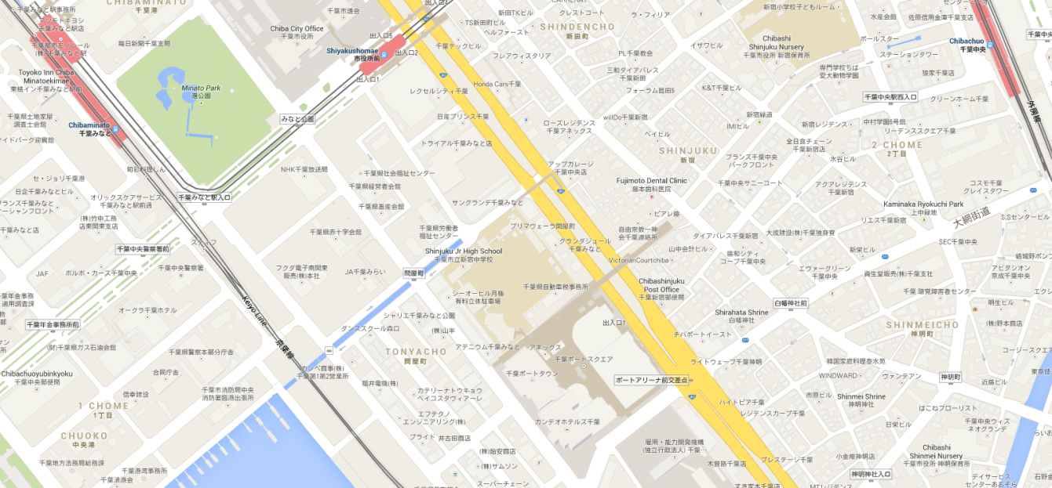
Chibaminato Station
Convenience store
Chiba Port Arena

----- Required documents -----

- Application
  - Required January 31
(January 15, if you need a VISA)
  - Mail to : noriyuki@kyj.biglobe.ne.jp
*Registration List form
*Team details for VISA form
*Passport (Copy of Page with photo)

----- Registration -----
  - Required March 23
*Agreement Form (Original)
*Medical Certificate (Original, in English)
(with sports Medic`s sign and Hospital`s stamp)
*Health Insurance Certificate (Original, in English )
(for any accidents that may occur at the competition)
*Passport (Original)
*Registration Fee (JPY Only)
*Karategi ( for Weight in) and Protectors ( for Check)



