Kyokushin World Federation Armenia
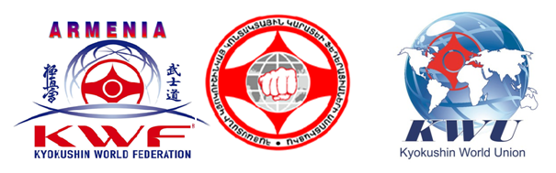 Statute
KYOKUSHIN KARATE ARMENIAN OPEN CHAMPIONSHIP

KWFA Karate National Federation chairman S. Gasparyan
Confirm _____________________________

1. GOAL and TASKS
- To develop Kyokushin karate in Armenia
- To increase the sportsmanship of sportsmen
- To implement the understanding “healthy soul in healthy body” in the future generation
- To find out thest rongest sports men and include them in the team for further Europe and World championships in 2018

2. THE PLACE and PASSING of CHAMPIONSHIP
Yerevan. 28 of April, 2018

- Charimain of declaring commission –Ghevond Martirosyan 27of March, 2018
- Courses of referees 28 of April 2018
- Beginning of championship 10:00; 28 of April 2018
Preliminaries
- Galaopening 15:00; 28of April 2018
- Conclusive 15:30; 28 of April 2018
- Awards of prizes 17:30; 28 of April 2018
Gala closing
3.AGE GROUPS AND WEIGHT CATEGORIES
All sportsmen of age 6-17 the following categories can take part in championship:
12-13 yers old  -35, -40,-45, -50, 50+ kg | 14-15 years old  -40, -45,-50, 50+ kg | 16-17 years old  -55, -60,-65, 65+ kg

The weight and age categories of all girls and women will be announces after receiving the applications.
The organizers of the championship have the right to change the weight categories after receiving all the application in the commission.

4. MEMBERS OF CHAMPIONSHIP
- The sposrtmen of the age from 6 up to 17 can take part in championship.
- All participants of the championship must have belt according to their qualification degree (kimono), proofofidentity, all participants up to 17 years old should wear protective equipments (helmet, gloves, protective shields for legs and for the area below the belt).
- Doctor reference

5. DURATION of FIGHT
12-17 years old 2 min. + 1 min. + scale + 1 min.

During the scaling process the following should be taken account:
(12–17) y.–2 kg
6. AWARDS
- The championship winners will be awarded bymedals, diplomas and gifts.
- As well as, giftes are established for the best technics and statement of willpower.

- Attention: All applications will be accepted until 15 of April 2018.
The application should be filled fully; otherwise it will not be accepted.
The team, which will delay the aplications, will leave the championship.
This statute is an official invitation for the Armenian Open Championship.

With respect

President of KWF Armenia Spartak Gasparyan
Main judge international Black Belt 8 Dan Andre Drewniak

E-mail: ds.club@mail.ru
Phone: (094) 49 49 49

