President
of Kyokushin-kan
International karate-do Organization

___________________H. Royama
«______»________________2018

Event Information

Asian Weight Wategory Championship
of Kyokushinkai-kan karate among
youth, juniors, girls, women and men

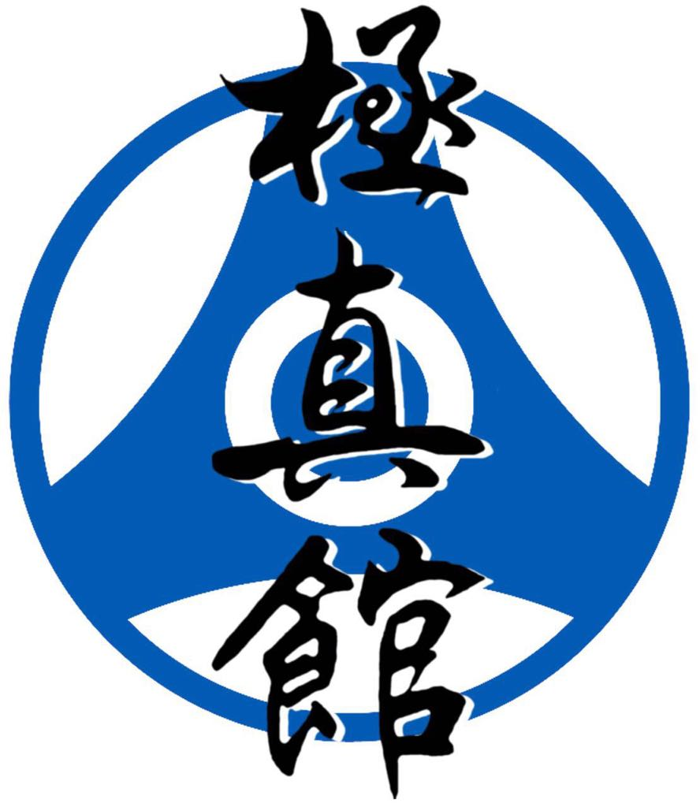

Astana, Kazakhstan 2018
Osu!
Dear representatives of Kyokushin karate.
The Republic National federation of Kyokushinkai-kan karate
invite you and your team to participate in the Asian Weight Category Championship of Kyokushinkai-kan karate among
youth, juniors, girls, women and men.

We glad to see you in Astana, Kazakhstan.

June 15-17, 2018

1. Conditions of participation in the Asian Championship

Representatives of the national federations KAN, IFK, KWF, WKO of Asian countries are allowed to participate in the Asian Championship who have been selected in the National Championships from 12 years and old with belt rank qualification from 6-th kyu and up.

2. Schedule of events:

DATE | TIME | EVENT | COMPETITORS
June 14 (Thursday) | Check in hotel  12⁰⁰ | Arival of judges | Judges
June 14 (Thursday) | Chek in hotel  12⁰⁰ | Arival of teams | Representatives,  Sportsmens,  Coaches,  Doctors, and spectators
June 15  (Friday) | 10⁰⁰ – 18⁰⁰ | Mandate commission | Coaches and  sportsmens
June 15  (Friday) | 14⁰⁰– 20⁰⁰ | Judge's seminar | Judges
June 15  (Friday) | 20⁰⁰– 21⁰⁰ | Meeting | Judges,  Representatives and coaches
June 16  (Satuday) | 10⁰⁰ – 13⁰⁰ | Preliminary fights (youth, juniors  and girls) | All teams
June 16  (Satuday) | 13⁰⁰ – 15⁰⁰ | Semi-finals and finals fights (youth, juniors and girls) | All teams

June 16  (Satuday) | 15⁰⁰ – 16³⁰ | Mandatory kata program  and final part  (men and women) | All teams
June 16  (Satuday) | 16³⁰ – 20⁰⁰ | Preliminary fights (men and women) | All teams
June 16  (Satuday) | 20⁰⁰ | Winner's reward ceremony  (youth, juniors and girls) | All teams
June 17  (Sanday) | 10⁰⁰– 13⁰⁰ | Semi-finals and finals fights (men and women) | All teams
June 17  (Sanday) | 13⁰⁰ – 14⁰⁰ | Breake | All teams
June 17  (Sanday) | 14⁰⁰ – 15⁰⁰ | Grand opening ceremony of the Championship | All teams
June 17  (Sanday) | 15⁰⁰ – 19⁰⁰ | Finals fights  (men and women) | All teams
June 17  (Sanday) | Reward after  each fight | Winner's reward ceremony
June 17  (Sanday) | 22⁰⁰ | Saionara party | By invitation only
June 18  (Monday) | Check out  from Hotel  12⁰⁰ | Departure | All teams

3. Payment information for all age categories:
Kumite – 50 USD;
Kata – 50 USD;
Kumite & kata – 80 USD;

The Republican National Federation of Kyokushinkai-kan karate assumes the following expenses:
- accommodation and meals of approved judges from June 14 till 18;
- accommodation and meals for fighters by kumite (men and women) from June 14 to 18;
- accommodation and meals for 1 representative from June 14 to 18;
- transfer for all fighters and approved judges along the route:
*Astana airport - hotel - Astana airport;
*Hotel - sports complex - hotel.
Fill in Appendix 5 - Accommodation form.

4. Registration for the application
Applications are accepted by e-mail: karate.rnfkk@gmail.com , (rnfkk1@gmail.com - copy)
Applications must be completed in the form 1, 2, 3, 4, 5, 6, 7, 8.
Application dead-line - 2018, May 15
Organization Commitee:
Chairman of the Organizing commitee – mr. Oxikbayev Omarkhan
Vice-president - Abilkairov Sairanbek (+7-701-52-111-08);
Head secretary - Azamat Khamzin (+7-707-540-55-12), rnfkk1@gmail.com;
International department secretary – Ruslan Alshimbayev (+7-701-543-35-28), karate.rnfkk@gmail.com

5. General rules
The Asian Championships by kumite will be held according to the KWU rules, which are posted on the official website - www.kwunion.com
The Asian Championships by kata will be held according to the Kyokushin-kan rules, which are posted on the official website - www.kyokushinkan.ru
(http://www.kyokushinkan.ru/kyokushinkan/kata_rules/index.wbp)

6. Summing-up
Kumite competitions in will be held on the system with elimination after one defeat.
- In each weight category among men and women two 3-rd places are played (fight for 3-rd place are not be held).
- In each weight category among youth, juniors and girls, 3-rd place is played out (fights for 3-rd place will be held).

Kata competitions in will be held in two round.
Preliminary round kata’s: Gekisai Sho

Final round: in the final round in each category there are 5 participants, who received the highest points in the qualifying round.
Kata by choice from the list in the final part of the Championship: Saifa, Kanku, Garyu, Seipai, Seienchin, Sushiho

Awarding of the winners and medalists of the Asian Championships
In the team event points are counted team members: for the first place - three points, for the second place - two points, for the third place - one point. In the case of an equal amount of points for two or more teams, the advantage is that which has more first places, then the second places are taken into account, then the third places. Lastly, the number of declared athletes is taken into account.
Winners and medalists (1-st, 2-nd, 3-rd places) of the Asian Championship are awarded with diplomas, medals and cups of the corresponding degrees.

Reporting documents on the conducted Asian Championship will be sending in electronic form to representatives of all participating countries and are posted on the official website www.kazkarate.kz within two weeks from the date of the competition.

7. Judges
The official list of accredited judges will be published on the official website - www.kazkarate.kz
- Chief judge of the Asian Championship - Royama Hatsuo, 9-th dan, Japan;
- Deputy Chief Judge of the Asian Championship by «Kumite» - Gabbasov Ramil, 5-th Dan, Russian Federation;
- Assistant Chief judge of the Asian Championships - Lim Igor, 3-rd dan, Kazakhstan
- Deputy Chief Judge of the Asian Championship by «Kata» - Miyama Khiroshi, 5-th dan, Japan

8. The venue of the Asian Championships
Astana city, Kazakhstan
Turan avenue, 4/2, Sport complex "Daulet".
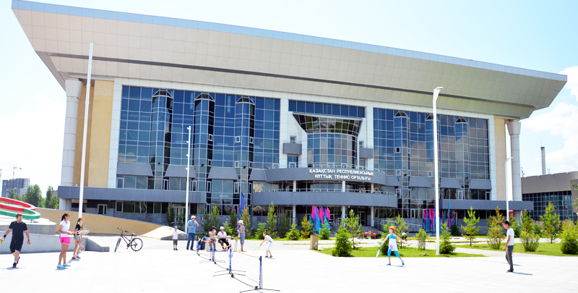

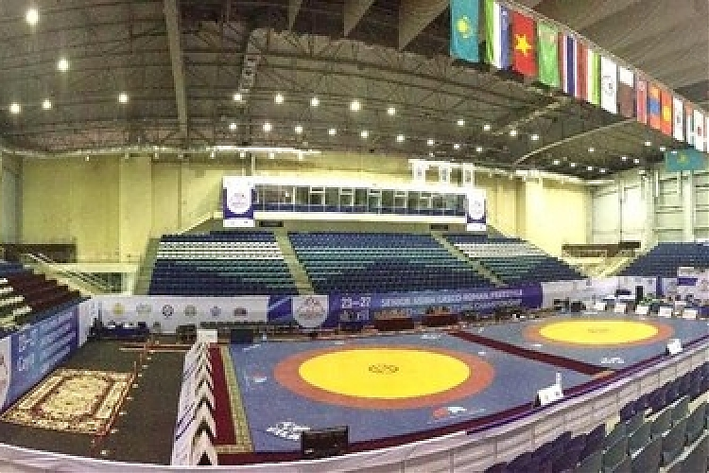

9. Composition of teams
- The official coach of the team;
- Men and women Asian Championship participants by «Kumite» - 1 person from the other Kyokushinkai Karate organization from Asian country in each weight category (conducting organization - 3 people);
- Men and women Asian Championship participants by «Kata» - 2 persons from the other Kyokushinkai Karate organization from Asian country (conducting organization - 5 people);
- Youth, juniors and girls Asian Championship participants by «Kumite» - 1 person from the other Kyokushinkai Karate organization from Asian country in each weight category (conducting organization - 5 people);
- Youth, juniors and girls participants - 1 person from the other Kyokushinkai Karate organization from Asian country in each weight category (conducting organization - 5 people);
- Official doctor team;
- Each Kyokushinkai karate organization of the Asian country provides a 1 judge and more.

10. Weight and age categories by Kumite

№ | Age category | Weight category (kg.)
1 | Men (18 yr. and older) | 60, 65, 70, 75, 80, 85, 90, 90+
2 | Women (18 yr. and older) | 50, 55, 60, 65,65+
3 | Juniors boys (16-17 yr.) | 55, 60, 65, 70, 70+
4 | Juniors girls (16-17 yr.) | 55, 60, 60+
5 | Youth boys (14-15 yr.) | 45, 50, 55, 60, 60+
6 | Youth girls (14-15 yr.) | 45, 50, 50+
7 | Youth boys (12-13 yr.) | 35, 40, 45, 50, 50+
8 | Youth girls (12-13 yr.) | 40, 45, 45+

The age of the participant is determined on the day of the mandate commission, that is, on June 15, 2018

11. Requirements for participants of competitions
The team’s representative submits the original application, each participant must have the following documents:
- passport;
- admission of a sports doctor to participate in Asian Championship (in English), issued not earlier than June 10, 2018;
- HIV antibodies test certificate (in English), issued not earlier than June 8, 2018;
- HBV antibodies test certificate (in English), issued not earlier than June 8, 2018;
- HCV antibodies test certificate (in English), issued not earlier than June 8, 2018;
- insurance contract valid at the time of the competition (original, in English);
- application form of the participant - Appendix No. 1 & 7.
- application form of the agreement from the guardian – appendix No. 3
- application form of the fighters agreement – appendix No. 8

12. Protective body guard equipment

Each participant admitted to the competition must have:
- white karate Dogi and belt, corresponding to the qualification of the participant;
- individual groin cup for men, youth and juniors - necessary;
- individual groin protection for women and girls - optional;
- shin guards with a closed foot of a white color (for youths, juniors and girls - necessary, for women - optional);
- gloves of white color (for youths, juniors and girls - necessary, for women - optional);
- head gear (helmet) of white color - for participants of both sexes (for youth, juniors and girls - necessary);
- girls and women breast pads with plastic inserts, with open abdomen on a fabric basis (open plastic parts are not allowed), for women, girls - necessary;
- mouth guard, should be white color – optional. If the dental braces are installed on the teeth, then the mouth guard is necessary.
All protective equipment must be provided for verification during the passage of the mandatory commission.

ATTENTION! All protective equipment is strictly individual!

13. Kumite rules

Men & women | men & women (18 yr. and older)
Belt rank | 2 kyu and up
Match duration (Up to Quarterfinal ) | 2 min + 2 min + 2 min
Match duration (Semifinals and finals) | 3 min + 2 min + 2 min + Weight + 2 min
Weight difference | 2 kg. and more

Juniors boys & girls | 16 -17 yr.
Belt rank | 6 kyu and up
Match duration (Up to Quarterfinal) | 2 min + 2 min + 1 min
Match duration (Semifinals and finals) | 2 min + 2 min + 1 min + Weight + 1 min
Weight difference | 2 kg. and more

Youth boys & girls | 14 -15 yr.
Belt rank | 6 kyu and up
Match duration (Up to Quarterfinal) | 2 min + 1 min + Weight + 1 min
Match duration (Semifinals and finals) | 2 min + 1 min + 1 + Weight + 1 min
Weight difference | 2 kg. and more

Youth boys & girls | 12 -13 yr.
Belt rank | 6 kyu and up
Match duration (Up to Quarterfinal) | 2 min + 1 min + Weight + 1 min
Match duration (Semifinals and finals) | 2 min + 1 min + 1 + Weight + 1 min
Weight difference | 2 kg. and more

All female competitors in Kata & Kumite must wear white T-shirts under Karate Dogi.

14. Kata rules

Men & women | men & women (18 yr. and older)
Belt rank | 6 kyu and up
Preliminary kata | Gekisai sho
Final Kata (only top 5) | Tsukino-kata, Saifa, Garyu, Seienchin, Seipai, Kanku, Sushihou

WELCOME TO ASTANA!



