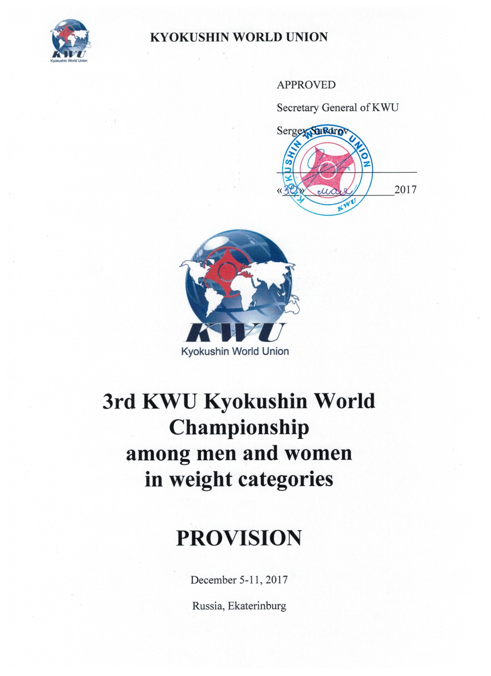
3rd KWU Kyokushin World Championship among men and women in weight categories
Dates: December 5-11, 2017.
Conditions of participation:
Representatives of national federations, who have passed national qualifying championships with calling of all interested groups of Kyokushin in a particular country aged 18 or above with the style qualification no less than 4th kyu are allowed to participate in the World Championship.
Time and place of national qualifying championships are decided jointly by the representatives of international organizations, listed in the “Members” section on www.kwunion.com.
The results of national qualifying championships should be sent to the KWU office
e-mail address champ@kwu2017.com.

Timeline of events:
Date | Time | Activity | Participants
December, 5th | all day | arrival of judges | judges
December, 6th | 14.00-20.00 | judging seminar | judges
December, 7th | all day | arrival of teams | leaders,  competitors,  coaches,  medics,  spectators
December, 7th | 10:00 – 14:00 | judging seminar | judges
December, 8th | 10:00 – 18:00 | credentials committee | team representatives, competitors
December, 8th | 10:00 – 14:00 | judging seminar | judges
December, 8th | 18:00 | common meeting | judges,  competitors,  leaders,  coaches
December, 9th | 10:00 | preliminary fights (up to finals) | all
December, 10th | 17:00 | opening ceremony | all
December, 10th | 17:30 | final bouts | all
December, 10th | after each bout | awarding | all
December, 10th | 22:00 | Sayonara party | by invitations
December, 11th | Departure from the hotel before 12.00 | date of departure | all

Financial conditions:
The entry fee will not be charged.

KWU covers the following charges:
- accommodation for the approved KWU judges in twin rooms of the accredited hotel (Full Board) – December, 5th – 11th;
- accommodation for competitors in twin rooms of the accredited hotel (Half Board) – December, 7th – 11th;
- lunches for competitors during the days of the tournament – December 9th - 10th, 2017.
- transfer for competitors and the approved KWU judges from the airport of Ekaterinburg to the hotel and back.

Applications:
Online registration is available on the official website of the Championship www.kwu2017.com.
Access to registration will be provided after the request of Kyokushin group head in particular country, and after the confirmation of holding national qualifying championships. The requests must be sent to the e-mail address of organizing committee champ@kwu2017.com.
Deadline for registration: 01.10.2017

Organizing committee – champ@kwu2017.com, +7-495-640-23-63

General rules:

The competitions will be kept by the rules of KWU, which are posted on the official website: www.kwunion.com

Judges:

The official list of the judges will be approved from the number of KWU accredited judges and will be published on the official website of the World Championship – www.kwu2017.com.
Those, who wish to take part in the judging seminar, which will be held on December 6th – 8th, 2017 in Ekaterinburg, should send a request to the e-mail address champ@kwu2017.com with phrase ‘judging seminar’ in the subject line. All the financial expenses shall be borne by themselves.
The Supreme Judge of the World Championship is Yury Trutnev, 5th Dan, Russia.
The Deputy Supreme Judge of the World Championship is Ramil Gabbasov, 5th Dan, Russia.

Awards:

Conditions of summarizing
The championship is a single-elimination tournament with elimination of the loosing competitor after one defeat. There will be two 3rd place winners in each weight category (no bouts for the 3rd place).

Awarding of champions and prizewinners
Champions and prize-winners (1st - 3rd places) are awarded with medals and diplomas as well as cups of corresponding grade.

Anti-doping control
Winners from 1st to 3rd places will go through the doping test in accordance with the rules of the World Anti-Doping Agency (WADA).

Location:
Palace of Sport Games (DIVS),
620027, Russia, Sverdlovsk region, Ekaterinburg, Olimpiyskaya Naberezhnaya, 3 (Metro station “Dynamo”)
http://divsport.ru/
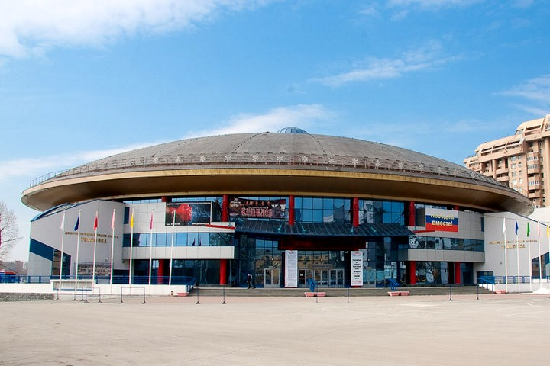

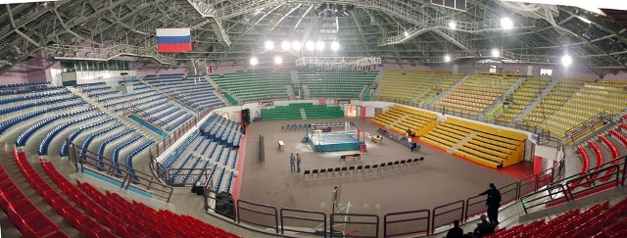

Composition of teams:
- official team coach – 1 person;
- competitors – 1 competitor from a country in each weight category;
- official team doctor.

The quota for WKO Shinkyokushinkai
The competitors from WKO Shinkyokushinkai, who wish to participate in the 3rd KWU Kyokushin World Championship, should contact their Branch Chiefs, who would inform about this request the WKO Shinkyokushinkai Headquarters.

Weight categories:

№ п/п | Age category (discipline) | Weight category
1 | men (18 years and older, kumite) | 60, 65, 70, 75, 80, 85, 90, 95, 95+
2 | women (18 years and older, kumite) | 50, 55, 60, 65, 70, 70+

The competitor’s age is defined as at the day of going through the credentials commission, which is December 8th, 2017

Documents to be provided by competitors:
During the credentials commission each competitor must have the following documents with him/her:
- passport;
- allowance of sports medic to participate in the competitions (in English), received no earlier than on November 8th, 2017;
- HIV antibodies test certificate (in English), given no earlier than on November 8th, 2017;
- HBV antibodies test certificate (in English), given no earlier than on November 8th, 2017;
- HCV antibodies test certificate (in English), given no earlier than on November 8th, 2017;
- agreement of insurance from accident, valid at the time of competitions (original, in English);
- written application of a competitor – attachment №1;

Equipment:
Each competitor, allowed to participate in the competitions, must have:
- white karategi and a belt, representing competitor’s qualification;
- individual groin cup: for men – mandatory, for women – voluntary;
- protectors for shin and insteps – mandatory for women;
- chest protector of a standard type - mandatory for women;
- gum shield (oral cavity protector), white colour – voluntary.
If there are brackets on teeth, gum shield is mandatory.

All protection items must have the mark of KWU.

All participants will have possibility to purchase protection items before the credentials commission.
ATTENTION! All protection items are individual, each competitor must have his own!
Duration of bouts:
Men:
Preliminary fights: 2 minutes + 2 minutes + 2 minutes.
Semi-final and final fights: 3 minutes + 2 minutes + 2 minutes.
Women:
Preliminary fights: 2 minutes + 2 minutes + 2 minutes.
Semi-final and final fights: 3 minutes + 2 minutes + 2 minutes.

Weight difference is not taken into account when the winner of the bout is defined.

Accommodation:
The accredited hotel of the 3rd KWU Kyokushin World Championship is ‘Atrium Palace Hotel’.
Ekaterinburg, Kuybysheva Street, 44

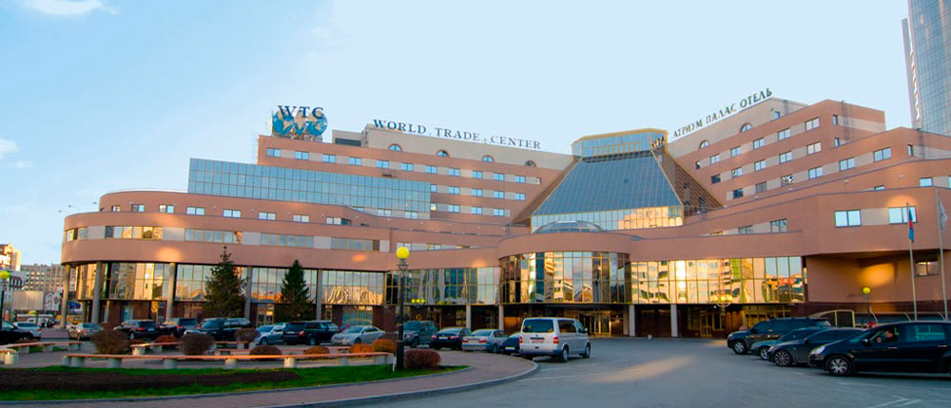

All categories of the participants will be accommodated in the 3 hotels, which are located on the same square with "Atrium Palace Hotel".
Hotel booking should be made only by the request to the e-mail champ@kwu2017.com with phrase «Hotels» in the subject line.
KWU will book the rooms for the registered competitors and selected judges on its own. There is no need in sending separate application for this purpose.

Welcome to Ekaterinburg!

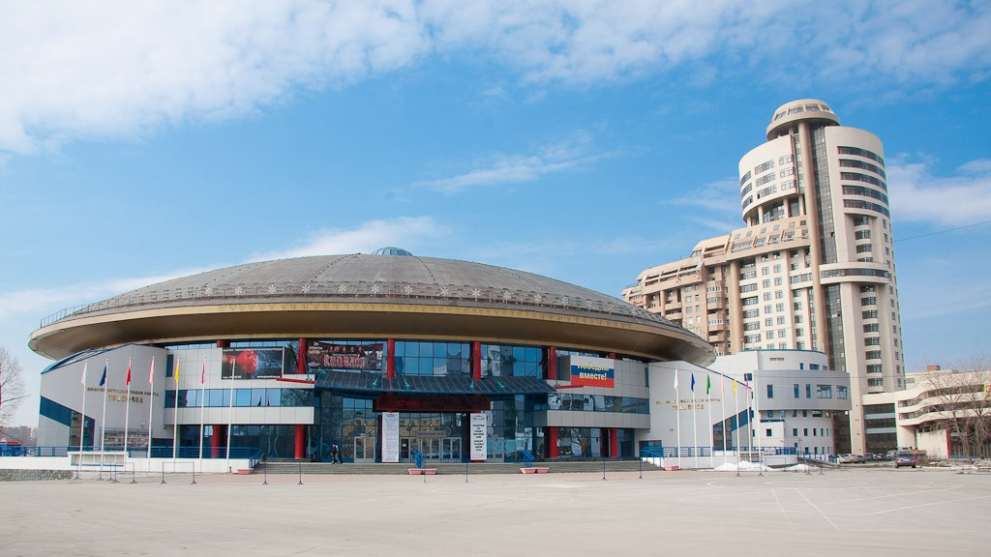



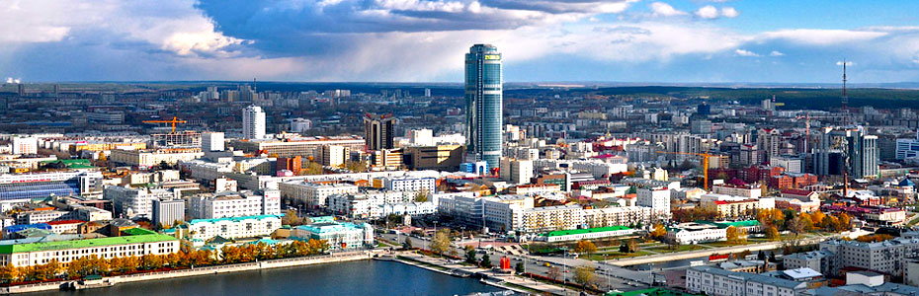

Attachment №1 – Competitor’s application
To the Supreme Judge Y. Trutnev

From___________________________________
(Full name)

Passport serial number _____№__________

Date of issue, issuing authority______________

______________________________________

APPLICATION FORM

I am requesting from you to let me _______________________________________________
(Full name)

__________________________________________________________________________________
participate in the 3rd KWU Kyokushin World Championship among men and women in weight categories, which will take place on December 5th – 11th, 2017 at Palace of Sport Games (DIVS), by the following address: Russia, 620027, Sverdlovsk region, Ekaterinburg, Olympiyskaya Naberezhnaya, 3.

In case of my injury and the associated impacts, as well as other adverse consequences while taking part in the competition, including from the use of techniques permitted or not permitted by the rules of the competition, and / or while in the room where these competitions are held, or preparation for this competition is held, I will not claim against the Supreme Judge, the organizers of the tournament, coaches and owners of the premises where competitions are held.
I am familiar with the rules of competition in Kyokushin, and I am completely aware that Kyokushin is a contact martial art, and I understand the possibility of injuries and other adverse effects received by me.
______________________________________________ __________________
Full name in handwriting Signature

__________________
date

