OFFICIAL INFORMATION LETTER.
3rd KWU Kyokushin World Championship
among men and women in weight categories

December 9-10, 2017, Russia, Ekaterinburg

Palace of Sports (DIVS)

Russia, Ekaterinburg, Olimpiyskaya Embankment, 3 (Metro station “Dinamo”)

“TIME TO BE UNITED!”

Weight categories
Men (18 years and older, kumite): 60, 65, 70, 75, 80, 85, 90, 95, 95+ kg.
Women (18 years and older, kumite): 50, 55, 60, 65, 70, 70+ kg.
The fighter’s age is determined as at the day of going through the credentials commission, which is December 8, 2017.

Conditions of participation and number of participants from each country
One fighter from a country is allowed in each weight category.

Representatives of national federations, who have passed national qualifying championships with calling of all interested groups of Kyokushin in a particular country at age of 18 years old and above with a style qualification not less than 4th kyu are allowed to participate in the World Championship.
Time and place of holding national qualifying championships are determined jointly by representatives of international organisations, listed in the “Members” section on www.kwunion.com.
The results of national qualifying championships should be sent to the KWU office e-mail address champ@kwu2017.com.

Participation of fighters from WKO Shinkyokushinkai
The fighters from WKO Shinkyokushinkai, who wish to participate in the 3rd KWU Kyokushin World Championship, should contact their Branch Chiefs, who would inform about this request the WKO Shinkyokushinkai Headquarters.

Judges
The official list of the judges will be approved from the number of KWU accredited judges and will be published on the official website of the World Championship – www.kwu2017.com.

People, who wish to take part in the judicial seminar, which will be held on December 6-8, 2017 in Ekaterinburg, should send a request to the e-mail address champ@kwu2017.com with phrase ‘judicial seminar’ in the subject line. All the financial expenses they pay themselves.

The Supreme Judge of the World Championship is Yuri Trutnev, the 5th Dan, Russia.
The Deputy Supreme Judge of the World Championship is Ramil Gabbasov, the 5th Dan, Russia.

General rules
The competitions will be held by the rules of KWU, which are posted on the official website: www.kwunion.com
Conditions of summarizing of the results
The championship is a single-elimination tournament with elimination of the loosing fighter after one defeat. There will be two 3rd place winners in each weight category (no bouts for the third place).

Timeline of events

05.12.2017 (Tuesday)  Arrival of judges  06.12.2017 (Wednesday)  14:00 – 20:00 – Judging seminar  07.12.2017 (Thursday)  Arrival of fighters, officials, trainers and country representatives  10:00 – 14:00 – Judging seminar  08.12.2017 (Friday)  10:00 – 18:00 – Credentials Committee  10:00 – 14:00 – Judging seminar  18:00 – 19:00 – Common meeting of fighters, judges, organizers and representatives | 09.12.2017 (Saturday)  10:00 - Preliminary fights (up to finals)  10.12.2017 (Sunday)  17:00 – Opening ceremony  17:30 – finals  22:00 – Sayonara Party  11.12.2017 (Monday)  Departure from the hotel (before 12 am) and departure

Location
Palace of Sports (DIVS),
620027, Russia, Ekaterinburg, Olimpiyskaya Embankment, 3 (Metro station “Dinamo”)
http://divsport.ru/

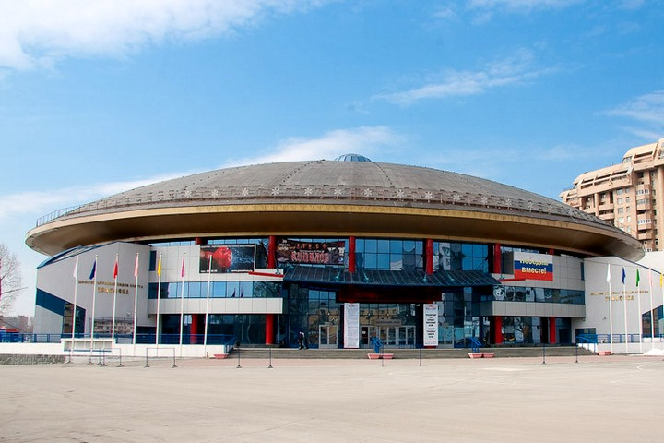
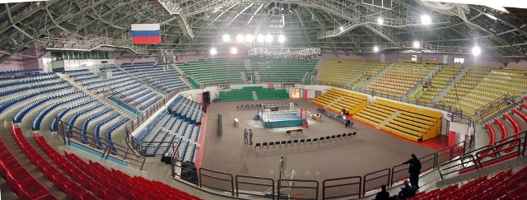

Accommodation
The accredited hotel of the 3rd KWU Kyokushin World Championship – ‘Atrium Palace Hotel’.
Ekaterinburg, Kuybysheva Street, 44

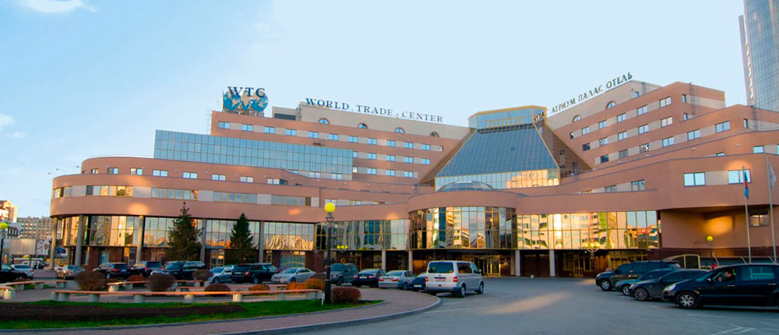

All categories of the participants will be accommodated in the 3 hotels, which are located on the same square with "Atrium Palace Hotel".
Hotel booking should be made only by the request to the e-mail - champ@kwu2017.com with phrase «Hotels» in the subject line.
KWU will book the rooms for the registered fighters and selected judges on its own. There is no need in sending separate application for this purpose.

Financial conditions

The entry fee from fighters will not be charged.

KWU covers the following charges:
- accommodation for the approved KWU judges in twin rooms of the accredited hotel (Full Board) – December, 5 – 11;
- accommodation for fighters in twin rooms of the accredited hotel (Half Board) – December, 7 – 11;
- lunches for fighters during the days of the tournament – December 9-10, 2017.
- transfer for fighters and the approved KWU judges from the airport of Ekaterinburg to the hotel and back.

Anti-doping control

The prize-winners from the 1st to the 3rd places will have to go through the doping test in accordance with the rules of the World Anti-Doping Agency (WADA).

Applications

Online registration is available on the official website of the World Championship www.kwu2017.com.
Access to registration will be provided after the request of Kyokushin group head in particular country, and after the confirmation of holding national qualifying championships. The requests must be sent to the e-mail address of organizing committee champ@kwu2017.com.
Deadline for registration: 01.10.2017

Organizing committee – champ@kwu2017.com, +7-495-640-23-63

General Secretary of KWU

Sergey Suvorov

