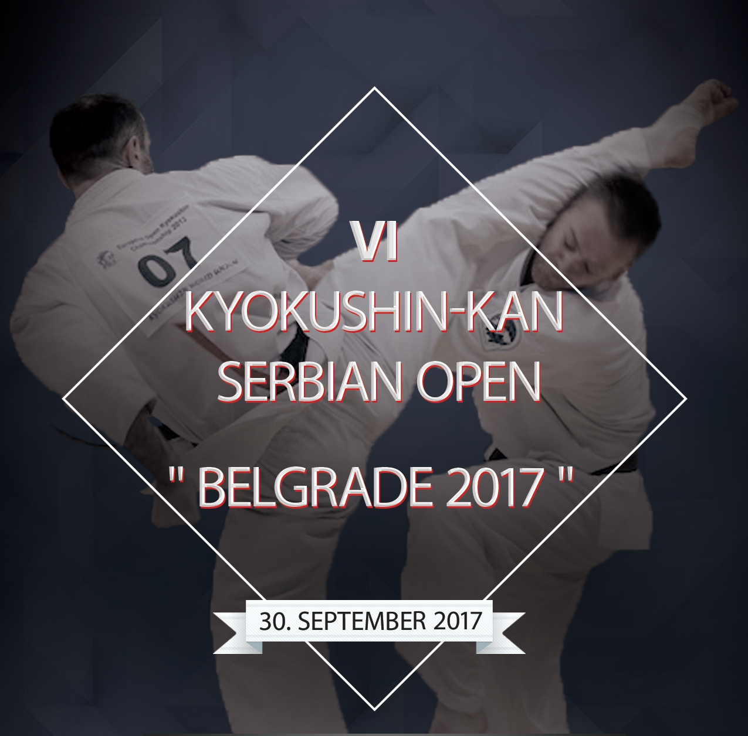
The application for the participation in
VI KYOKUSHIN-KAN SERBIAN OPEN “BELGRADE 2017”
(FOR KIDS, YOUTH, CADETS, JUNIORS & SENIORS) IN KATA & KUMITE
(Belgrade, September 30, 2017)

From ___________________ ______________________________________________________
the official naming of an organization

№ | Competitor’s last name / given name | Date of birth (yyyy/mm/dd) | Age | Weight  (kg) | Height  (cm) | Kyu / Dan | Team representative / coach
1
2
3
4
5
…

To the VI Kyokushin-kan karate Serbian Open “Belgrade 2017” tournament ___________________________ persons are admitted (write out the number in words)

Team representative ______________________________________________

President : ___________ name ___________________ seal /______ sign ________/

