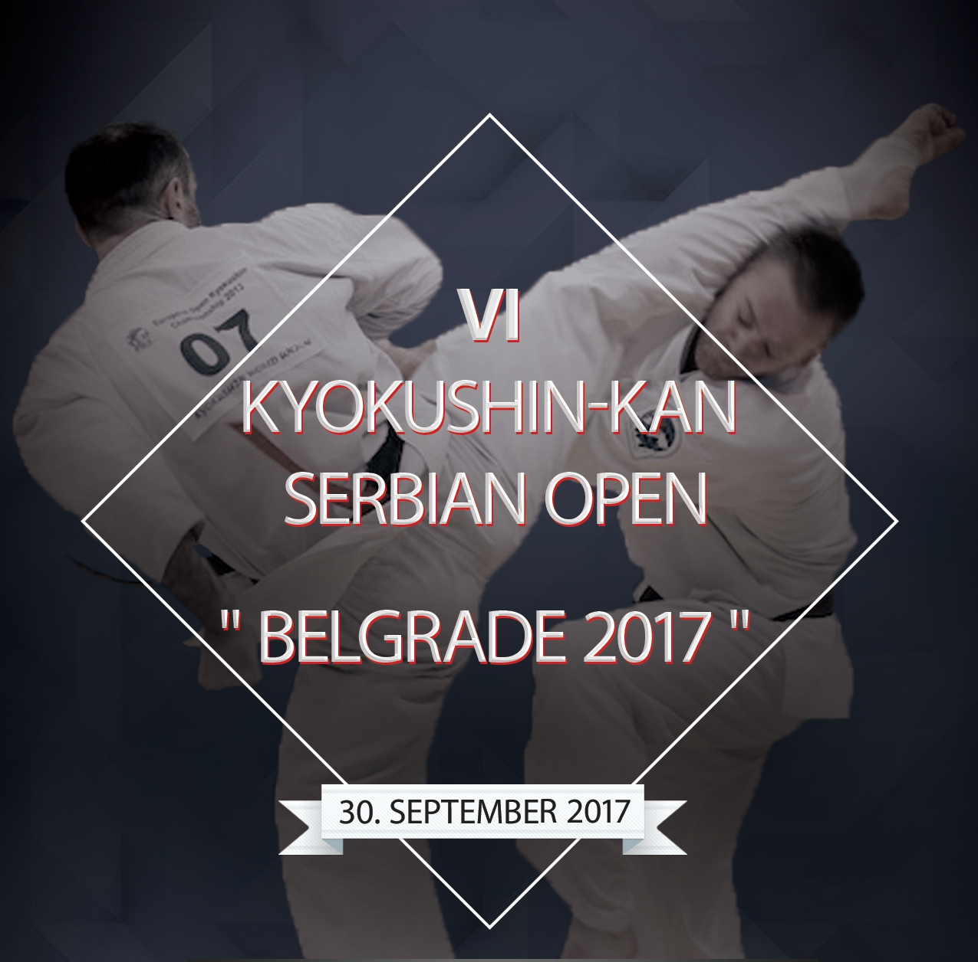

All participants of the sport competitions in the ages under 18 shall have written permission of both parents (or of one parent if there is only one parent, or of the official guardian) with signs of the parents.

AGREEMENT
(For younger than 18 years of age)

We ,_Last name, first name _____________________________________________________
passport ______________ #_____________________________________________________
issued at ____________________________________________ date of issue______________
and Last name, first name ___________________________________________
passport ______________ #_____________________________________________________
issued at ____________________________________________ date of issue______________

give our permission for the participation of our son (daughter) ______name___________________________________________________________________

in the VI Kyokushin-kan Serbian Open Tournament “BELGRADE 2017” , that will take place on September 30, 2017, in Belgrade.
In case our child gets injured during the championship we will not put forth any accusations against the championship organizers and coaches.

«__ ___» ______________ 2017 ___________ /________________________________ /
sign last name, first name

«__ ___» ______________ 2017 ___________ /________________________________ /
sign last name, first name

