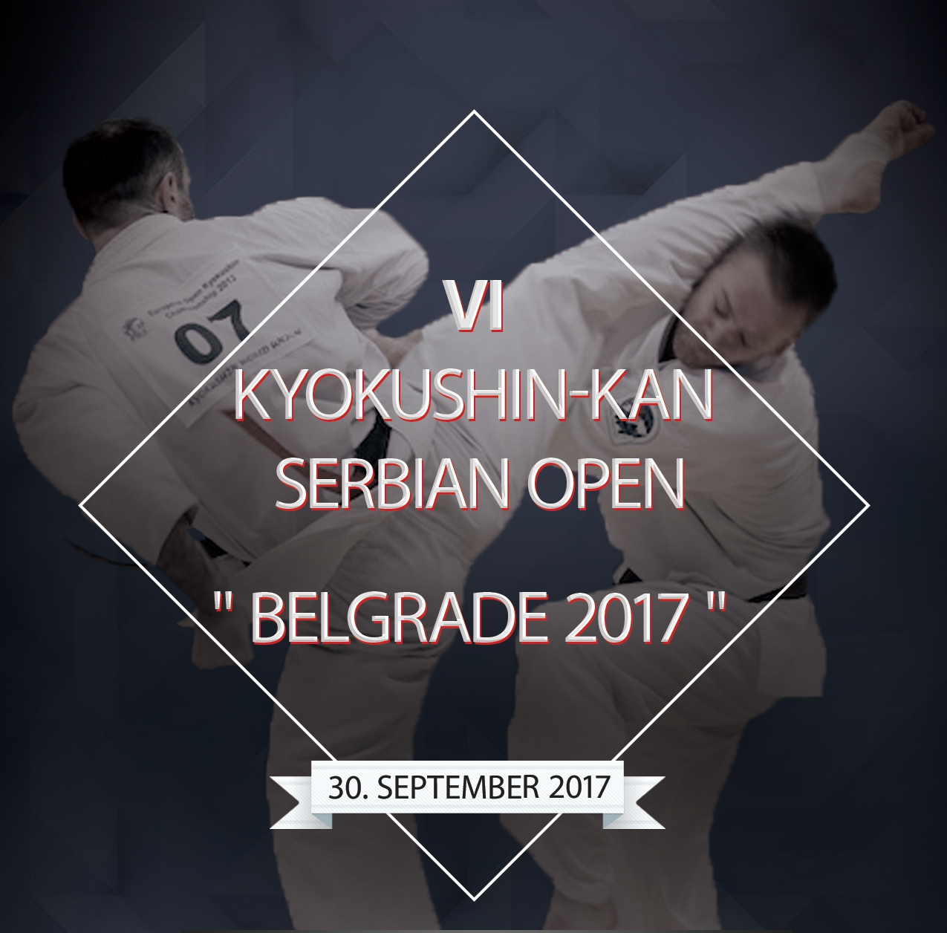

AGREEMENT FOR ADULTS

I, ______name___________________________________________________________________,

accept to participate in the VI Kyokushin-kan Serbian Open Tournament “BELGRADE 2017”, that will take place on 30th of November 2017, in Belgrade.

In case I get injured during the championship I will not put forth any accusations against the championship organizers and coaches.

«__ ___» ______________ 2017 ___________ /________________________________ /
sign last name, first name

