

 BULGARIAN KARATE 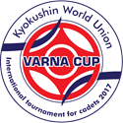 KYOKUSHIN FEDERATION

Varna, “Tsar Simeon” №31

Application form for International tournament for cadets
KWU “Varna Cup”
18-21 years
07.07.2017, Kamchiya

Full name
Photo is obligatory | the picture in karate gi (portrait digital photo, jpeg format, high resolution) – to attach (as a separate file) to the application
Date of birth
Country
International Organization
Qualification (Kyu, Dan)
Weight
Height
Sports results

