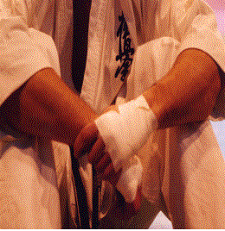

:

RECOMMENDED MATERIAL: 2 Karate gi, training shoes, equipment, rain jacket, towel and toiletries and sleep bag.
NEEDED PROTECTIONS: Shin and feet guards, knee pads and gloves.

CLINIC ACTIVITIES. Clinic registration consists of accommodation in hostel for two nights (29th-1st) including
- ATTITUDE all meals, 8 specific kumite training classes and video learning sessions.
- ATTACK PLEASE, MAKE SURE TO BE IN GOOD SHAPE.

- DEFENSE
- STRIKE BACK Clinic admission until last day 20/04/2017
- ANTICIPATION
- STRATEGY 1
- MENTAL TRAINING YOUR SUCCESS DEPENDS ON YOUR SPIRIT.
TRAINING WITH CHAMPIONS WILL HELP YOU REACHING YOUR GOALS.

INTERESTED IN ATTENDING, CONTACT YIN-YANG CLUB.

Fixed line: +34 945 25 11 38 Mobile: +34 699 75 65 78
E-mail: karate@gimnasio-yinyang.com
Web: www.gimnasio-yinyang.com

