
あああ
あああ
ああ
あああ
あああ

【Invitation Letter】

KARATE GRANDPRIX 2017

The 4th KWF International Karate Tournament

Nov, 2016
Dear Sirs,
It is my and KWF’s pleasure to invite you and your students to KARATE GRANDPRIX 2017 on March 26, 2017 in Chiba-Tokyo, Japan.

We will hold this International Tournament under the official auspices of the Chiba City Board of Education, Chiba Prefectural Board of Education and the Mainichi Newspaper.

We would highly appreciate your co-operation and participation.

We would welcome many competitors to join, the number of participants in each class is unlimited.
Very sincerely yours,
OSU



Shihan Noriyuki Tanaka
Country Representative of K WF in Japan

DATE :

March 26 , 2017

COMPETITION VENUE :
Chiba Port Arena ( refer to page 5 “COMPETITION VENUE”)

SCHEDULE :
8:45 a.m. Referee/Judge meeting 9:30 a.m. Opening Ceremony
9:45 a.m. Competition Begins

REGISTRATION AND WEIGHT-IN :
13:00 . March 25 Lobby of Hotel Tokyo Bay Makuhari
( refer to page 6 “ACCOMODATIONS” )

REGISTRATION FEE :
6,000 JPY : (No.1 – No.39)
8,000 JP Y : (No.40 – No.50)
Required fee in cash at the REGISTRATION AND WEIGHT-IN (March 25)

P RE-REGISTRATION DEADLINE:
January 31, 2017 ( If you need VISA , January 15, 2017 !!!)
Only accept mails from the dojo representative.

GENERAL RULES:
K WU Rules for all divisions.
Jodan-Mawashi-Geri and Gedan-Mawashi-Geri are allowed for the category of Boys and Girls except Jodan-Hiza-Geri.
Rules are the subject to change appropriately.

JUDGES:
Selected by the KWF JAPAN

AWAR DS:
Trophy or Medal for top three
* Two competitors for third place (No game for the third place)

LIABILITY:
Participate on your risk!
Required Parental Permission Signature for the under 18.

COMPETITION VENUE:
Chiba P ort Arena
http://chibacity.spo-sin.or.jp/shisetu/arena-top/arena-main.html
1 -20 Tonya-cho , Chuo-ku, Chiba tel: + 81 43 241 0006
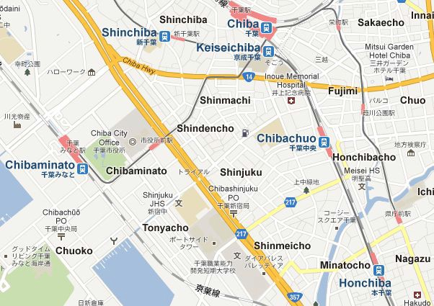

★

Chiba Port Arena
~8minutes by train to JR Chibaminato Station from JR Kaihin-Makuhari Station.
~15 minutes by walk from JR Chibaminato Station.

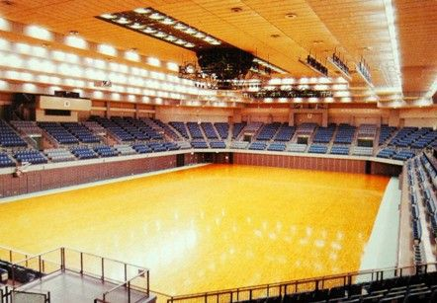
ACCOMONDATIONS: Official Hotel of 【KARATE GRANDPRIX 2017】
APA HOTEL & RESORT in Makuhari= [Tokyo Bay Makuhari]
http://www.apahotel.com/makuhari/english/guest.html
2-3 Hibino, Mihama-Ku, Chiba-city, Chiba, Japan 261-0021
tel: + 81 43 296 1111 fax: + 81 43 296 0977 e-mail ah-rmk@apa.co.jp
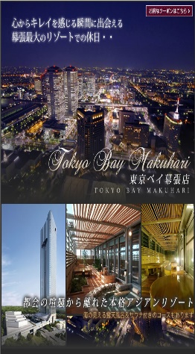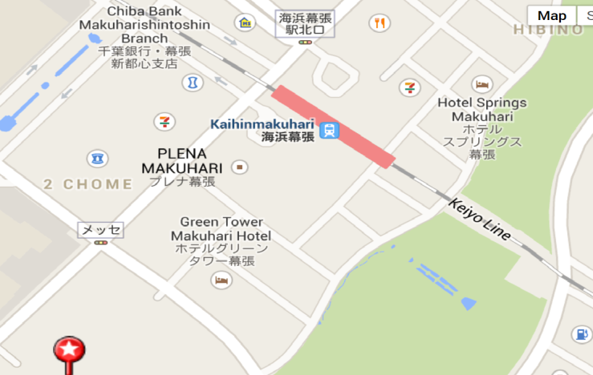

APA HOTEL & RESORT in Makuhari=[Tokyo Bay Makuhari]
(8 minutes by walk from Kaihinmakuhari Station.)
One building truly stands out among the Tokyo Bay Area`s modern skyline.
Designed by world-famous architect Kenzo Tange , this spectacular triangular tower
is Japan`s highest –reaching hotel building and a Landmark of Makuhari New city.

IMPORTANT – the official hotel “APA Hotel” Reservation
- KWF Japan would not reserve the hotel. Please reserve the APA Hotel on your own responsibility through “Booking.com” http://www.booking.com/.

- Recommend you to reserve the amount of rooms ASAP since rooms are limited. Cancellation would be accepted until just before the lodging.

- Recommend you to reserve the Hotel during the November since VISA documents required the Hotel information ( Hotel Name, TEL, Reserved Date ) .

- If the APA hotel was unavailable, recommend you to reserve the others nearby the APA hotel through “Booking.com” http://www.booking.com/ on your own responsibility.

  - Other Recommended Hotels
    - Hotel New Otani Makuhari (0.1km from APA Hotel)
    - Hotel Francs (0.3km from APA Hotel)
    - Hotel Green Tower (0.3km from APA Hotel)

- Tutorial for “Booking.com”
  - Visit “Booking.com” http://www.booking.com/
  - Select language
  - Enter the Destination or hotel name, please enter “Chiba”
  - Enter “check in date”, “check out date”, “guests”
  - Click “Search”
  - Click “choose your room” and reserve APA Hotel

ACCESS from Narita Airtport
- Go to the KEISEI BUS booth in front of the ARRIVAL in Narita
http://www.narita-airport.jp/en/guide/service/list/svc_32.html#t2
- Buy the Ticket (JPY 900) towards to “APA HOTEL & RESORT in Makuhari” and check the Number of Bus Stop.
- Go to the Bus Stop and wait.(the Bus departures every 40~60 min)
http://www.keiseibus.co.jp/global/en/timetable.php?id=22

Lunch during the Tournament
Able to buy the Lunch nearby the stadium(Chiba Port Arena).
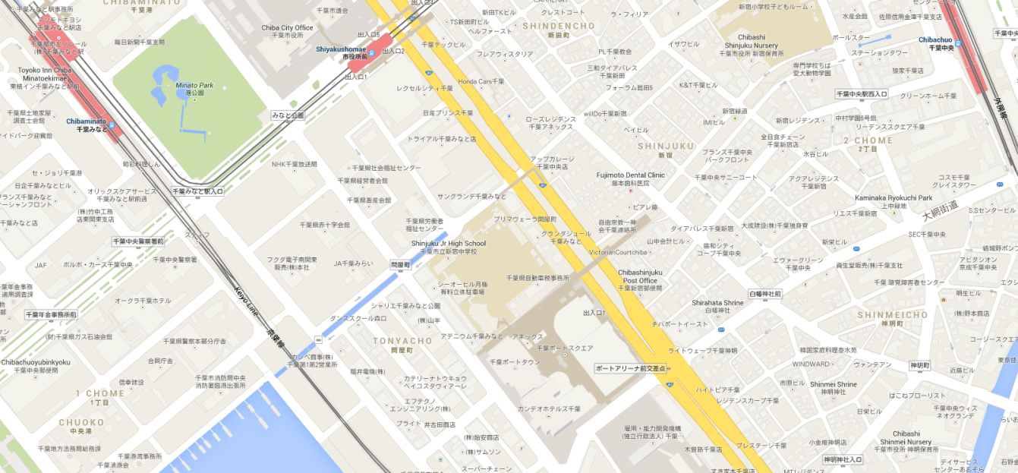
Chibaminato Station
Convenience store
Chiba Port Arena

----- Required documents -----

- Application
  - Required January 31 (January 15, with VISA)
  - Mail to kwfchiba@yahoo.co.jp
*Agreement form (Copy)
*Registration List
*Team details for VISA
*Passport (Copy of Page with photo)

----- Registration -----
  - Required March 25
*Agreement Form (Original)
*Medical Certification (Original)
*Health Insurance Certificate (Original)
*Passport (Original)
*Registration Fee for the tournament (JPY Only)
*Karate gi ( for Weight in)



http://w w w.chiba-tou r.jp/in dex.htm l

