5th KWU Kyokushin Open Youth World Championship (kumite)
Bulgaria, Varna, December 3rd – 4th, 2016
Dates of keeping: December 3rd – 4th, 2016
Conditions of access to participation:
Representatives of national federations, who have passed national qualifying championships with calling in all interested groups of Kyokushin in a particular country at age from 12 to 17 years old with a style qualification not less than 6th kyu are able to participate in the World Championship.
Time and place of keeping national qualifying championships are defined jointly by representatives of international organizations, listed in the “Members” section on www.kwunion.com
Timeline of events:
Date | Time | Event | Participants
November, 30th | Till 13:00 | arrival of judges | judges
November, 30th | 15:00-18:00 | judicial seminar | judges
December, 1st | 10:00-12:00 | judicial seminar | judges
December, 1st | 16:00-19:00 | judicial seminar | judges
December, 2nd | 10:00 | arrival of teams | Leaders,  team representatives, fighters, coaches,  medics, audience
December, 2nd | 10:00 -12:00 | judicial seminar | judges
December, 2nd | 11:00-17:00 | credentials commission | team representatives, fighters
December, 2nd | 18:00-19:00 | Press- conference | judges, fighters,  leaders, team representatives, coaches
December, 3rd | 10:00-19:00 | preliminary fights (up to finals) | all
December, 4th | 10:00 | ceremonial opening | all
December, 4th | 10:30 | final fights | all
December, 4th | 15:00 | awarding ceremony | all
December, 4th | 19:00-21:00 | Sayonara party | all
December, 5th | Departure from a hotel before 12:00 | date of departure | all

Financial conditions:
The entry fee will not be charged.

The host organization covers the following charges:
- Transfer to and from hotel for fighters, judges, one country representative and one coach of the country
- Accommodation for judges at the accredited hotel
- Accommodation for fighters, one representative and one coach of the country at the accredited hotel
- Lunch for judges (November, 30th – December, 4th), fighters, one representative and one coach of the country (December, 3rd – 4th) during the days of tournament
-Flights Sofia-Varna-Sofia for fighters, one representative and one coach of the country

Applications for participation:
Deadline for preliminary applications (appendix number 1): up to October, 1st, 2016
WARNING! The following documents shall be provided together with a preliminary application:
1) photo in karategi (portrait photography in electronic form, jpeg format, high resolution)
2) attachment № 4 - completed by each fighter
3) application for accommodation (attachment № 5)
4) list of judges (attachment № 2)
5) group preliminary application for the whole delegation (attachment 6)

The deadline for the final applications – November, 1st, 2016 (Note: No final application to be accepted if preliminary application was not submitted.) The final application is sent by e-mail, it must contain all the necessary signatures and seals.

Applications are accepted only if filled in accordance with prescribed form (Attachment № 1). The application must be signed by the presidents of the national federations of the country, whose fighters are in the application.

Applications are accepted by e-mail address:
e-mail: kwuchamp2016@gmail.com
contact phone numbers:
+ 7(495)640-23-63 – KWU office
+359888438384, +359 88 5775059– Prolet Vasileva

Original applications (hard printed copy) with all necessary documents are brought by the team representatives during the credentials commission.

General rules:

The competitions will be kept by the rules of KWU, which are posted on the official web-site: www.kwunion.com

Judges:

Two persons from the country who have judicial experience of such level of competitions are allowed.
The exact number is defined by organizing committee of competitions. Application for judges is represented by attachment 2.

Awards:

Conditions of summarizing
Sports competitions in kumite are kept on basis of retirement after one loss. Each weight category has two third places.

Awarding of champions and prizewinners
Champions and prize-winners (1st-3rd places) are awarded with medals and diplomas as well as cups of corresponding grade.

Anti-doping control
Winners from 1st to 3rd places will go through doping test in accordance with the rules of the World Anti-Doping Agency (WADA).

Location:
Sports arena: Palace of Culture and Sports, Hall “Congress”
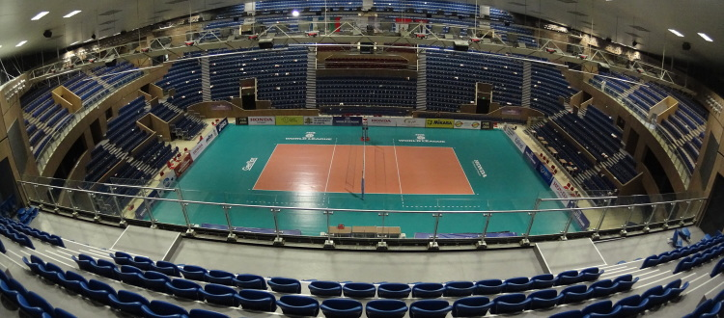
Location: Bulgaria,Varna
https://goo.gl/maps/xm719jmwuuP2
Capacity: 5116 places
Address: Varna, Bulgaria blvd. "Knyaz Boris I" №115
Website: http://palaceofvarna.com/?portfolio=%D0%B7%D0%B0%D0%BB%D0%B0-%D0%BD%D0%B0%D1%86%D0%B8%D0%BE%D0%BD%D0%B0%D0%BB%D0%BD%D0%B0

Weight categories and composition of teams:
Composition of fighters and amount composition of a team:
- official team representative;
- fighters – 1-4 people from a country in each weight category (number of people – 1 fighter from 1 federation: KI, IFK, KWF, WKO);
- team doctor (if any).

№ | Age category (discipline) | Weight category
1 | boys (12 -13 full years, kumite) | 35, 40, 45, 50, 55, 55+
2 | girls (12 -13 full years, kumite) | 40, 45, 50, 50+
3 | boys (14-15 full years, kumite) | 45, 50, 55, 60, 65, 65+
4 | girls (14-15 full years, kumite) | 45, 50, 55, 60, 60+
5 | boys (16-17 full years, kumite) | 55, 60, 65, 70, 75, 75+
6 | girls (16-17 full years, kumite) | 50, 55, 60, 65, 65+

The fighter’s age is defined as at the day of going through the credentials commission, which is December, 2nd, 2016.

Obligations of fighters
During the credentials commission, leader of the team gives the original application (hard printed copy), and each fighter must have the following documents with him/her:
- Passport or birth certificate(for juvenile participants);
- allowance of sports medic to participate in competitions (in English);
- written permission to participate from both parents
- HIV antibodies test certificate (in English);
- HBV antibodies test certificate (in English);
- HCV antibodies test certificate (in English);
- agreement of insurance from accident, valid at the time of competitions (original, in English);
- written application of a fighter – attachment №3;

Protection:
Each fighter, allowed to participate in competitions, must have:
- white karategi and a belt, representing fighter’s qualification;
- individual groin shell: for boys– mandatory, for girls– voluntary;
- protectors for shin and insteps – mandatory for girls;
- knee pads, elbow pads – voluntary;
- handguards – mandatory;
- headgear– mandatory for all;
- chest protector of a standard type - for girls;
- gum shield (oral cavity protector), white colour – voluntary.
If there are brackets on teeth, gum shield is mandatory.
All protection items must have a mark of KWU.
All participants will have possibility to purchase protection items before the credentials commission.
ATTENTION! All protection items must be individual; each fighter must have his own!

Schedule of fights:
Age category “boys/ girls” (12-13 years)
Younger boys (12-13 years)
Preliminary fights: 2 minutes + 1 minute + weighing (weight difference 2.5 kg and more) + 1 minute
Semi-final and final fights: 2 minutes + 1 minute + weighing (weight difference 2.5 kg and more) + 1 minute

Younger girls (12-13 years)
Preliminary fights: 2 minutes + 1 minute + weighing (weight difference 2.5 kg and more) + 1 minute
Semi-final and final fights: 2 minutes + 1 minute + weighing (weight difference 2.5 kg and more) + 1 minute

Age category “boys/ girls” (14-15 years)
Elder boys (14-15 years)
Preliminary fights: 2 minutes + 1 minute + weighing (weight difference 2.5 kg and more) + 1 minute
Semi-final and final fights: 2 minutes + 1 minute + 1 minute + weighing (weight difference 2.5 kg and more) + 1 minute

Elder girls (14-15 years)
Preliminary fights: 2 minutes + 1 minute + weighing (weight difference 2.5 kg and more) + 1 minute
Semi-final and final fights: 2 minutes + 1 minute + 1 minute + weighing (weight difference 2.5 kg and more) + 1 minute

Age category “boys/girls” (16-17 years)
Boys (16-17 years)
Preliminary fights: 2 minutes + 2 minutes + weighing (weight difference 3 kg and more) + 1 minute
Semi-final and final fights: 2 minutes + 2 minutes + 1 minute + weighing (weight difference 3 kg and more) + 1 minute
Girls (16-17 years)
Preliminary fights: 2 minutes + 2 minutes + weighing (weight difference 3 kg and more) + 1 minute
Semi-final and final fights: 2 minutes + 2 minutes + 1 minute + weighing (weight difference 3 kg and more) + 1 minute

Accommodation:
The accredited hotel:
“Hotel &SPA Azalia”
Sts. Constantine & Helena Resort, 9006 Varna, Bulgaria
http://www.azaliahotel.com/ru/
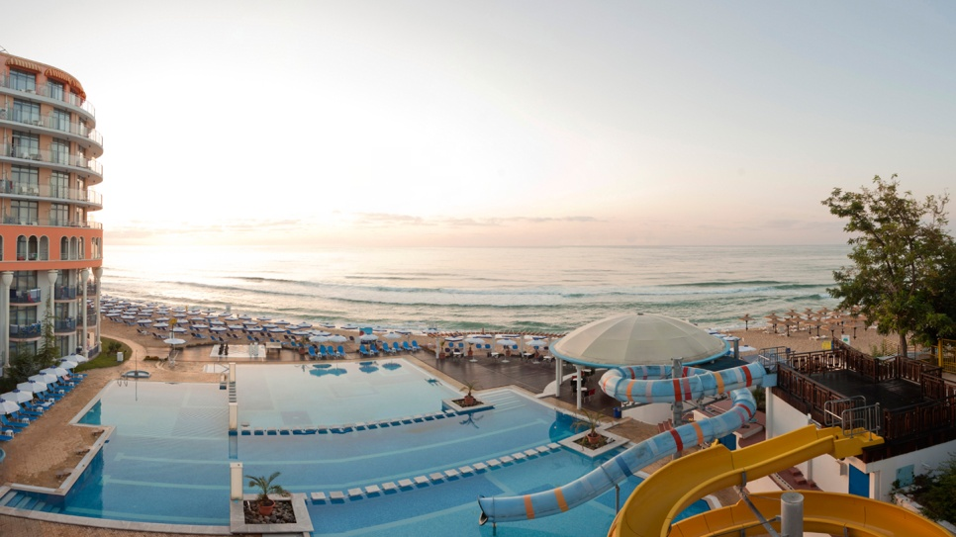
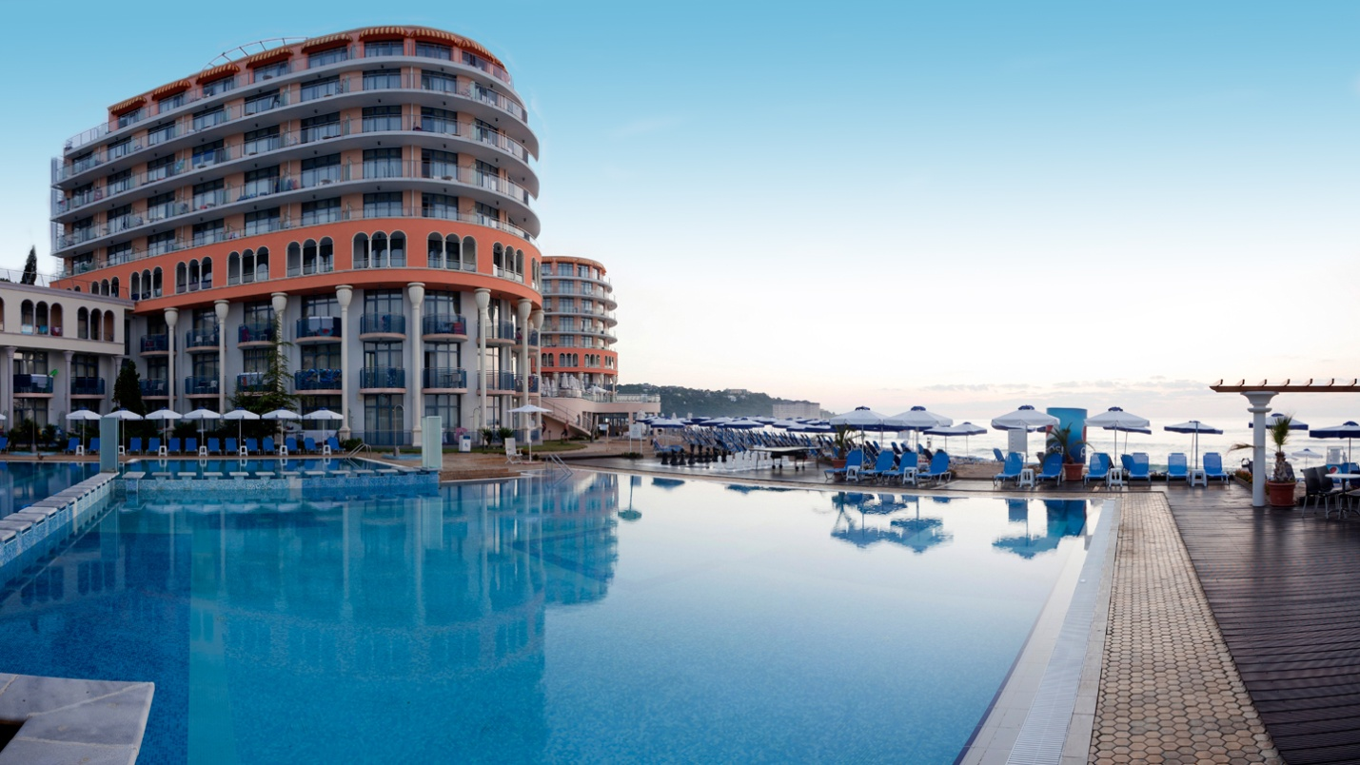

and “Hotel & SPA Astera”
Golden Sands Resort, 9007 Varna, Bulgaria
http://www.asterahotel.com/ru/
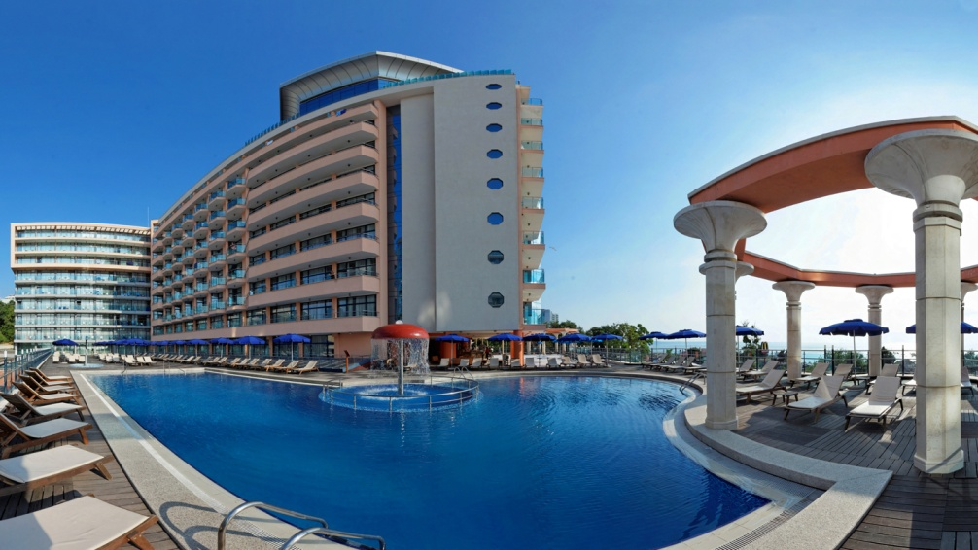

You will be met by at the airport by KWU representatives. There will be transportation organized to the hotel.

Attachment 1 – Application form

Application
for participation in 5th KWU Kyokushin Open Youth World Championship (kumite)
December 3rd – 4th, 2016, Bulgaria, Varna

from __________________________________________________________________________________________________
(The Name of the Country)

№ | Last and first names  (in English) | Date of birth  (full) | Male/  Female | Kyu, Dan | Exact weight | Coach | Country | International  organisation

Name of team representative ________________________________________
Contact number of team representative ________________________________________

Signature and stamp of the president
of the Country National Federation _________________________________________________/L.S./

Signature and stamp of the president
of the Country National Federation _________________________________________________/L.S./

Signature and stamp of the president
of the Country National Federation _________________________________________________/L.S./
Attention! The pictures for each fighter must be attached to the application form - the picture in karategi (portrait digital photo, jpeg format, high resolution)

Attachment 2 – Application for judges

5th KWU Kyokushin Open Youth World Championship (kumite)
December 3rd – 4th, 2016, Bulgaria, Varna
Application for judging

№ | Last and first names  (full) | Date of birth,  age (number of full years) | Male/  Female | Common experience of judging | Kyu, Dan | Country | International organization | Main tournaments, which were served as a judge (provide full names of tournaments with a location and date of carrying, an approximate number of bouts served by judge as a: supreme judge, referee on tatami, side judge etc. | Shirt size | Contact number | Languages knowledge (languages, that judge can speak)
1
2

Signature and stamp of the president
of the Country National Federation _________________________________________________/L.S./

Signature and stamp of the president
of the Country National Federation _________________________________________________/L.S./

Signature and stamp of the president
of the Country National Federation _________________________________________________/L.S./

Attachment 3 – Fighter application

To the Supreme Judge of the championship

From_____________________________________________ (Full name)

Passport serial number____________________________

Date of issue, issuing authority________________________

_________________________________________________

APPLICATION FORM

I am requesting from you to let me, ________________________________________________
(Full name)

__________________________________________________________________________________
participate in 5th KWU Kyokushin Open Youth World Championship (kumite), which will take place on December 3rd – 4th, 2016 at: Bulgaria, Varna, blvd. "Knyaz Boris I" №115 Sports arena: Palace of Culture and Sports, Hall “Congress”.
In case of my injury and the associated impacts, as well as other adverse consequences while taking part in the competition, including from the use of techniques permitted or not permitted by the rules of the competition, and / or while in the room where these competitions are held, or preparation for this competition is held, I will not claim against the Supreme Judge, the organizers of the tournament, coaches and owners of premises where competitions are held.
I am familiar with the rules of competition in Kyokushin, and I am completely aware that Kyokushin is a contact martial art, and I understand the possibility of injuries and other adverse effects received by me.

_________________________________________________ __________________
Full name in handwriting Signature

__________________
date

Attachment 4

This attachment shall be filled-in by fighters and sent to the e-mail together with a preliminary application
Full name
Photo is obligatory | the picture in karategi (portrait digital photo, jpeg format, high resolution) – to attach (as a separate file) to the application
Date of birth
Country
International Organization
Qualification (Kyu, Dan)
Weight
Height
Sports results

Attachment 5 – Application for accommodation

Application for the accommodation in the Hotel
of guests and participants of Kyokushin Open Youth World Championship

from_____________________________________________________________________
__________________________________________________________________

Full name and telephone number of team’s representative ___________________________
__________________________________________________________________________

№ | Full name | Type of room (single, double, etc.)  (in case if you pay for yourself) | Date of arrival | Date of departure | Time of arrival to the hotel
1
2

Signature and stamp _______________________________________________/L.S./

Attachment 6 – Common application of a whole delegation, including supporters.
COMMON APPLICATION
for participation 5th KWU Kyokushin Open Youth World Championship (kumite)
December 3rd – 4th, 2016, Bulgaria, Varna

from __________________________________________________________________________________________________
(The Name of the Country National Federation)

№ | Last and first name of a delegation member (as stated in passport) | Status (team representative, fighter, coach, judge, medic, guest) | Date of birth  (full) | Passport data (serial number, issuing authority, issue date, expiration date, nationality | Kyu, Dan (if any) | Date of arrival to Khabarovsk, kind of transport, flight number, destination of arrival | Date of departure from Khabarovsk, kind of transport, flight number, point of departure | Location of accommodation in Khabarovsk (accredited hotel or independently.

Name of team representative ________________________________________
Contact number of team representative ________________________________________

Signature and stamp of the president
of the Country National Federation _________________________________________________/L.S./

