KWU Kyokushin World Championship among men and women in weight categories.
Dates of keeping: September 29th – October 05th, 2015
Conditions of access to participation:
Representatives of national federations, who have passed national qualifying championships with calling in all interested groups of Kyokushin in a particular country at age from 18 years old with a style qualification not less than 4th kyu are able to participate in the World Championship.
Time and place of keeping national qualifying championships are defined jointly by representatives of international organisations, listed in the “Members” section on www.kwunion.com
Timeline of events:
Date | Time | Event | Participants
September, 29th | all day | arrival of judges | judges
September, 30th | 14.00-20.00 | judicial seminar | judges
October, 1st | all day | arrival of teams | Leaders,  team representatives, fighters, coaches,  medics, audience
October, 1st | 10:00 – 14:00 | judicial seminar | judges
October, 2nd | 10:00 – 18:00 | credentials commission | team representatives, fighters
October, 2nd | 10:00 – 14:00 | judicial seminar | judges
October, 2nd | 18.00 | common meeting | judges, fighters,  leaders, team representatives, coaches
October, 3rd | 10.00 | preliminary fights (up to finals) | all
October, 4th | 16.00 | ceremonial opening | all
October, 4th | 16.30 | final fights (awarding after ending of each bout) | all
October, 4th | 19:00 | departure from Arena Platinum | all
October, 4th | 22.00 | sayonara | according to invitations
October, 5th | Departure from a hotel before 12.00 | date of departure | all

Financial conditions:
The entry fee will not be charged.

The host organization covers the following charges:
- Transfer to and from hotel for fighters, judges, one country representative
- Accommodation of judges at the accredited hotel
- Accommodation of fighters and one representative of the country at the accredited hotel
- Lunch for judges, fighters and representatives during the days of tournament

Applications for participation:
Deadline for preliminary applications (appendix number 1): up to July 1st, 2015
WARNING! The following documents shall be provided together with a preliminary application:
1) photo in karategi (portrait photography in electronic form, jpeg format, high resolution)
2) attachment № 4 - completed by each fighter
3) application for accommodation (attachment № 5)
4) list of judges (attachment № 2)
5) group preliminary application for the whole delegation (attachment 6)

The deadline for the final applications - September 1st, 2015 (Note: No final application to be accepted if preliminary application was not submitted.) The final application is sent by e-mail, it must contain all the necessary signatures and seals.

Applications are accepted only if filled in accordance with prescribed form (Attachment № 1). The application must be signed by the presidents of the national federations of the country, whose fighters are in the application.

Applications are accepted by e-mail address:
e-mail: kwuchamp@gmail.com
contact phone number: +7 (495) 640-23-63

Original applications (hard printed copy) with all necessary documents are brought by the team representatives during the credentials commission.

General rules:

The competitions will be kept by the rules of KWU, which are posted on the official web-site: www.kwunion.com

Judges:

Two persons from the country who have judicial experience of such level of competitions are allowed.
The exact number is defined by organizing committee of competitions. Application for judges is represented by attachment 2.

Awards:

Conditions of summarizing
Sports competitions in kumite are kept on basis of retirement after one loss. Each weight category has two third places.

Awarding of champions and prizewinners
Champions and prize-winners (1st-3rd places) are awarded with medals and diplomas as well as cups of corresponding grade.

Anti-doping control
Winners from 1st to 3rd places will go through doping test in accordance with the rules of the World Anti-Doping Agency (WADA).

Location:

12 Dikopoltseva street, Platinum Arena, Khabarovsk (Russia),
http://www.platinumarena.ru/

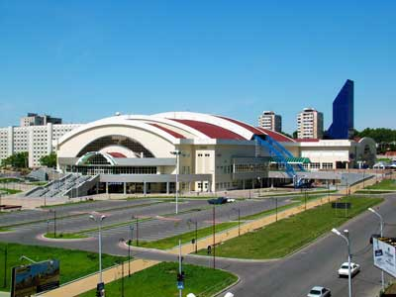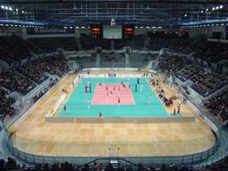

Weight categories and composition of teams:

Composition of fighters and amount composition of a team:

- official team representative;
- fighters – 1 person from a country in each weight category;
- team doctor (if any).

№ | Age category (discipline) | Weight category
1 | men (18 years and older, kumite) | 60,65,70,75,80,85,90,95,95+
3 | women (18 years and older) | 55,60,65,70,70+

The fighter’s age is defined as at the day of going through the credentials commission, which is October, 02nd , 2015.

Obligations of fighters
During the credentials commission, leader of the team gives the original application (hard printed copy), and each fighter must have the following documents with him/her:
- passport;
- allowance of sports medic to participate in competitions (in English);
- HIV antibodies test certificate (in English);
- HBV antibodies test certificate (in English);
- HCV antibodies test certificate (in English);
- agreement of insurance from accident, valid at the time of competitions (original, in English);
- written application of a fighter – attachment №3;

Protection:
Each fighter, allowed to participate in competitions, must have:
- white karategi and a belt, representing fighter’s qualification;
- individual groin shell: for men – mandatory, for women – voluntary;
- protectors for shin and insteps – mandatory for women;
- chest protector of a standard type - mandatory for women;
- gum shield (oral cavity protector), white colour – voluntary.
If there are brackets on teeth, gum shield is mandatory.
All protection items must have a mark of KWU.
All participants will have possibility to purchase protection items before the credentials commission.
ATTENTION! All protection items must be individual, each fighter must have his own!

Schedule of fights:
Men:
Preliminary fights: 2 minutes + 2 minutes + 2 minutes.
Semi-final and final fights: 3 minutes + 2 minutes + 2 minutes.
Women:
Preliminary fights: 2 minutes + 2 minutes + 2 minutes.
Semi-final and final fights: 3 minutes + 2 minutes + 2 minutes.

Accommodation:
Accredited hotel for accommodation of fighters «Intourist»
Amurskiy boulevard 2, Khabarovsk city, Russia, http://intour-khabarovsk.ru/

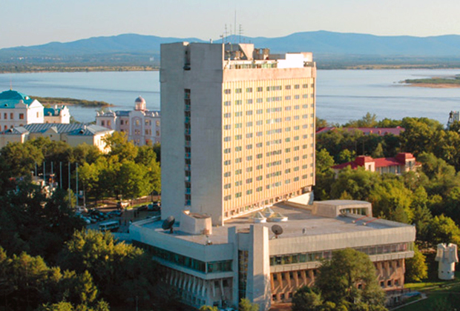

Accredited hotel for accommodation of judges «Olympic»
Dikopoltseva street 26A, Khabarovsk, Russia, http://www.hotelolympik.ru/

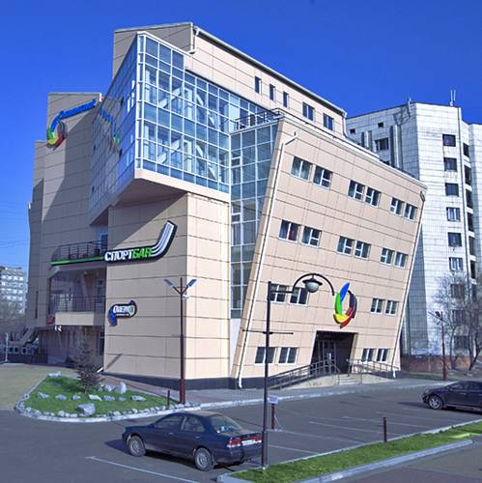

ATTENTION! Judges will live apart from fighters.
Representatives of KWU will meet you in the airport of arrival. There will be transfer to the accredited hotel organize

Welcome to Khabarovsk!
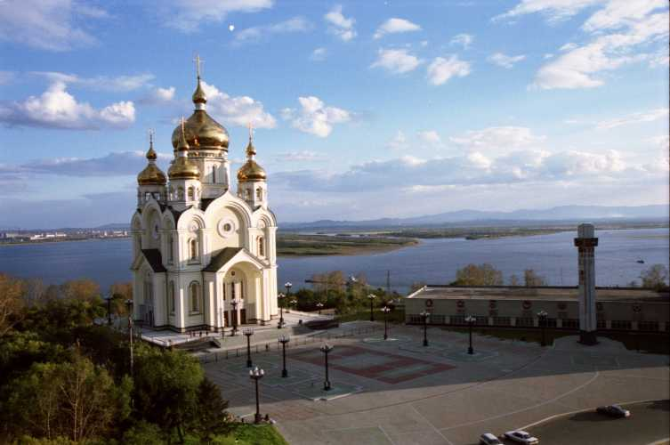


Attachment 1 – Application form

Application
for participation in Kyokushin World Championship among men and women
September 29-th – October 05-th, 2015, Khabarovsk

from __________________________________________________________________________________________________
(The Name of the Country)

№ | Last and first names  (in English) | Date of birth  (full) | Kyu, Dan | Exact weight | Coach | Country | International  organisation

Name of team representative ________________________________________
Contact number of team representative ________________________________________

Signature and stamp of the president
of the Country National Federation _________________________________________________/L.S./

Signature and stamp of the president
of the Country National Federation _________________________________________________/L.S./

Signature and stamp of the president
of the Country National Federation _________________________________________________/L.S./

Attention! The pictures for each fighter must be attached to the application form - the picture in karategi (portrait digital photo, jpeg format, high resolution)
Attachment 2 – Application for judges

Kyokushin World Championship among men and women
September 29-th – October 05-th, 2015, Khabarovsk
Application for judging

№ | Last and first names  (full) | Date of birth, age (number of full years) | Common experience of judging | Kyu, Dan | Country | International organisation | Main tournaments, which were served as a judge (provide full names of tournaments with a location and date of carrying, an approximate number of bouts served by judge as a: supreme judge, referee on tatami, side judge etc. | Shirt size | Contact number | Languages knowledge (languages, that judge can speak)
1
2

Signature and stamp of the president
of the Country National Federation _________________________________________________/L.S./

Signature and stamp of the president
of the Country National Federation _________________________________________________/L.S./

Signature and stamp of the president
of the Country National Federation _________________________________________________/L.S./

Attachment 3 – Fighter application

To the Supreme Judge Y.P. Trutnev

From______________________________________________
(Full name)

Passport serial number____________________________

Date of issue, issuing authority________________________

_________________________________________________

APPLICATION FORM

I am requesting from you to let me, ________________________________________________
(Full name)

__________________________________________________________________________________
participate in Kyokushin World Championship among men and women, which will take place from September 29th until October 05th, 2015 at: Russia, Khabarovsk, 12 Dikopoltseva street, « Platinum Arena », Khabarovsk.
In case of my injury and the associated impacts, as well as other adverse consequences while taking part in the competition, including from the use of techniques permitted or not permitted by the rules of the competition, and / or while in the room where these competitions are held, or preparation for this competition is held, I will not claim against the Supreme Judge, the organizers of the tournament, coaches and owners of premises where competitions are held.
I am familiar with the rules of competition in Kyokushin, and I am completely aware that Kyokushin is a contact martial art, and I understand the possibility of injuries and other adverse effects received by me.

_________________________________________________ __________________
Full name in handwriting Signature

__________________
date

Attachment 4
This attachment shall be filled-in by fighters and sent to the e-mail together with a preliminary application
Full name
Photo is obligatory | the picture in karategi (portrait digital photo, jpeg format, high resolution) – to attach (as a separate file) to the application
Date of birth
Country
International Organization
Qualification (Kyu, Dan)
Weight
Height
Sports results

Attachment 5 – Application for accommodation

Application for the accommodation in the Hotel
of guests and participants of Kyokushin World Championship

from_____________________________________________________________________
__________________________________________________________________

Full name and telephone number of team’s representative ___________________________
__________________________________________________________________________

№ | Full name | Type of room (single, double, etc.)  (in case if you pay for yourself) | Date of arrival | Date of departure | Time of arrival to the hotel
1
2

Signature and stamp _______________________________________________/L.S./

Hosting organisation covers the following costs:
- Transfer to and from hotel for fighters, judges and one country representative
- Accommodation of judges in the accredited hotel
- Accommodation of fighters and 1 country representative in the accredited hotel
- Lunch for judges, fighters and representatives during tournament days

Attachment 6 – Common application of a whole delegation, including supporters.
COMMON APPLICATION
for participation in Kyokushin world championship among men and women
September 29-th – October 05-th, 2015, Khabarovsk

from __________________________________________________________________________________________________
(The Name of the Country National Federation)

№ | Last and first name of a delegation member (as stated in passport) | Status (team representative, fighter, coach, judge, medic, guest) | Date of birth  (full) | Passport data (serial number, issuing authority, issue date, expiration date, nationality | Kyu, Dan (if any) | Date of arrival to Khabarovsk, kind of transport, flight number, destination of arrival | Date of departure from Khabarovsk, kind of transport, flight number, point of departure | Location of accommodation in Khabarovsk (accredited hotel or independently.

Name of team representative ________________________________________
Contact number of team representative ________________________________________

Signature and stamp of the president
of the Country National Federation _________________________________________________/L.S./

