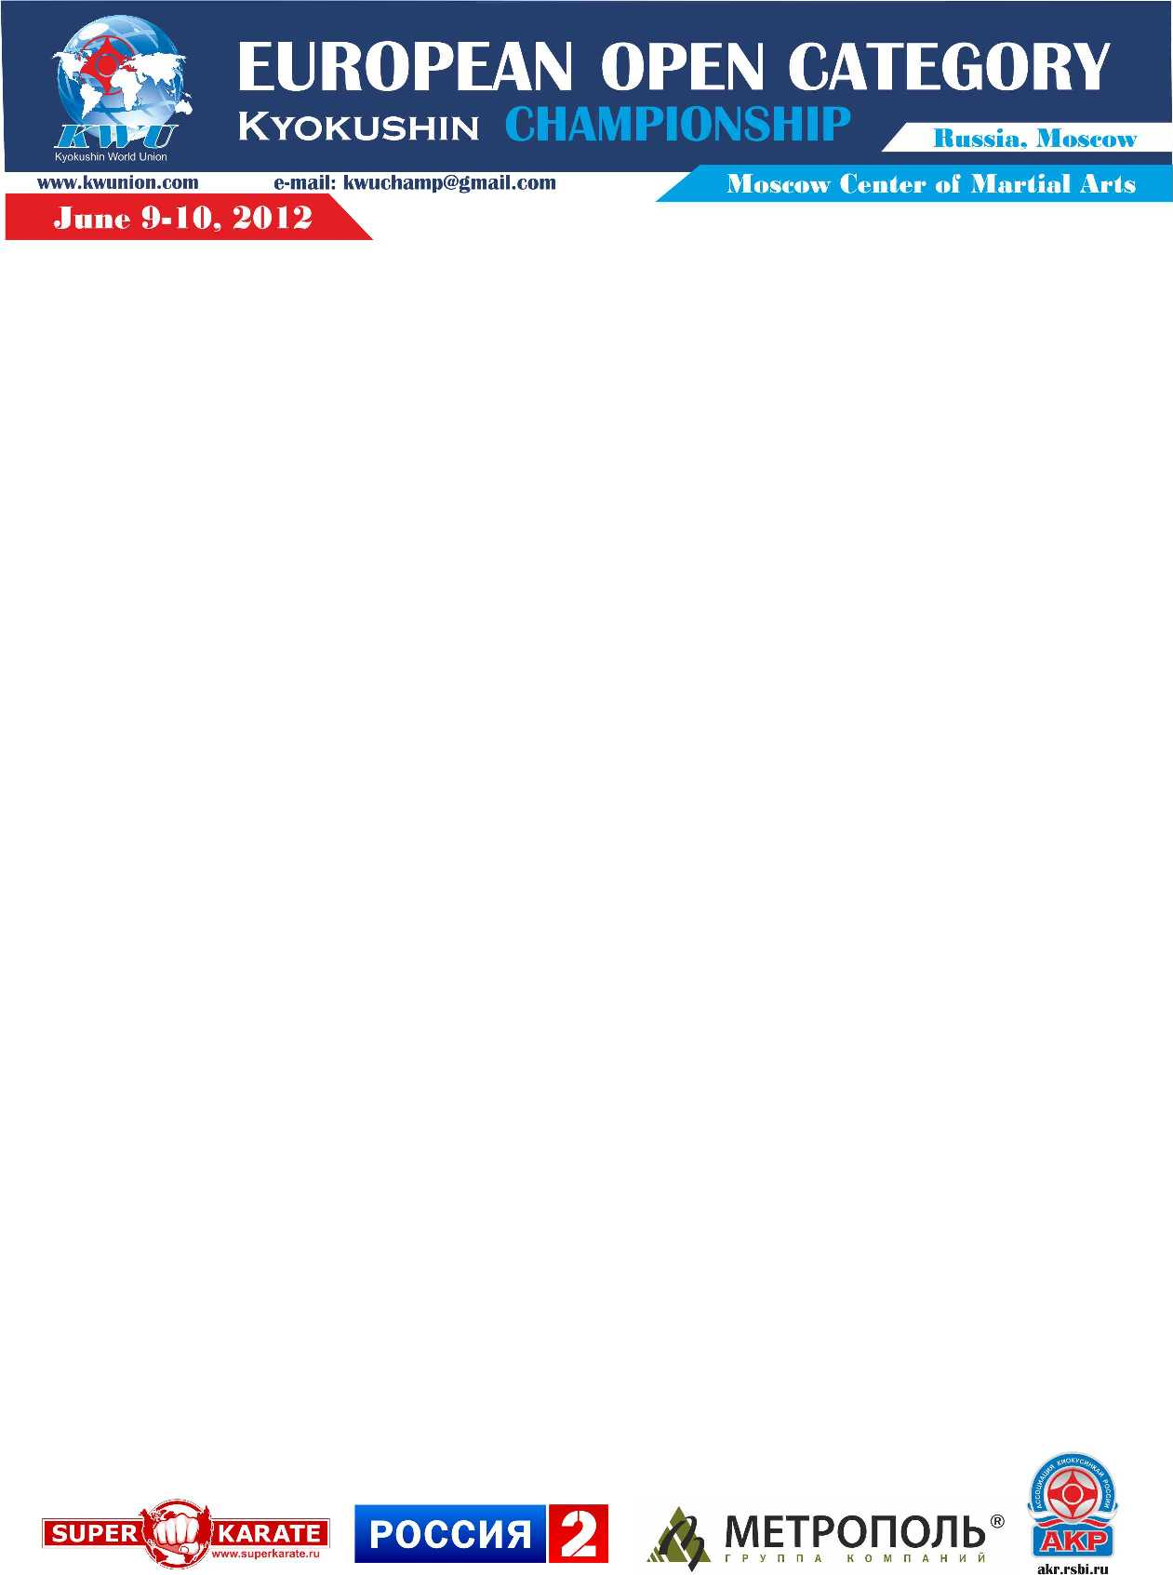

Attachment 5 – Information of the hotel

Hotel «Katerina Park»

The address: 11, Kirovogradskaya Str., Moscow, Russia.

Metro: Prazhskaya (1st wagon from the center)
Yuzhnaya (1st wagon from the center)

The room category | Cost Rub/a day
Single (1 person) | 2600
Double (2 persons) | 3200

In cost of the accommodation are included:
- Breakfast «buffet»
- Wi-Fi in each point of the hotel
- Mini-bar with daily replenishment (without alcohol drinks)
- Fitness-center (Finnish and Turkish saunas, gym, jacuzzi)

On June 8th, 9th and 10th of 2012 the buses will run between the hotel and sports complex.

