APPROVED
By Co-Chair of Kyokushin World Union
Y.P. Trutnev

___________________

«____»_____________2012

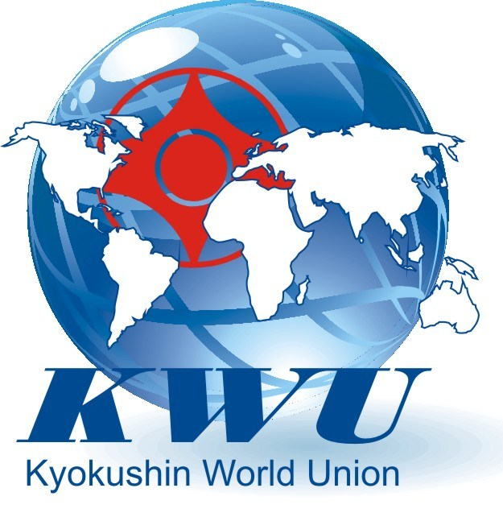

European Open
Kyokushin Championship
men
(kumite, tameshiwari)

Moscow, 2012
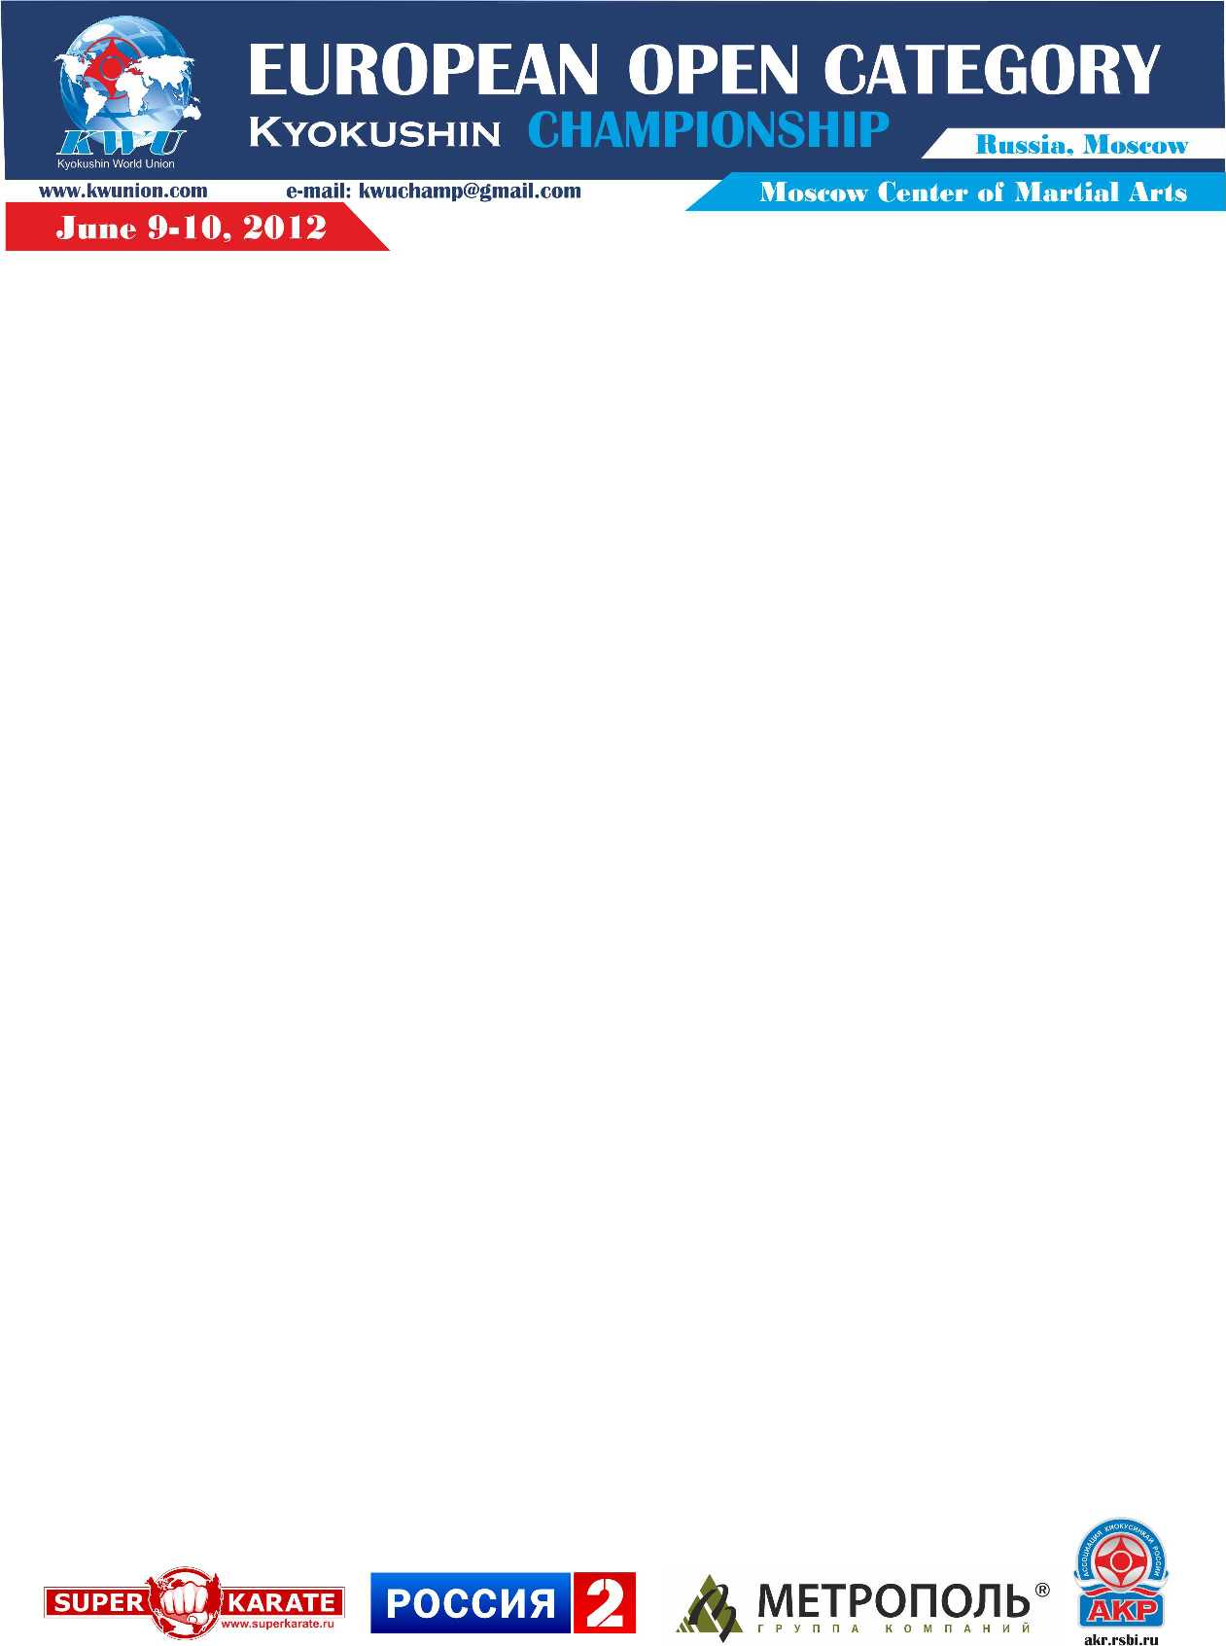

- Date & place
Location: Russia, Moscow, Warshawskoye shosse, 118, Bldg. 1
Moscow Center of Martial Arts

Dates: 08th-11th of June, 2012

Check-in: June 8, 2012 from 15:00 to 17:00
Moscow, Warshawskoye shosse, 118, Bldg. 1
Moscow Center of Martial Arts

The draw: date of the draw will be set in the working process by the organizing committee of competition. After the date of finishing the acceptance of applications (April 25, 2012) the closed draw with the participation of representatives of all the international organizations-members of KWU (RKA) will take place.

2. Organization and management of the European Championship

2.1 The organizers of competitions
- Kyokushin World Union
- Ministry of Sport, Tourism and Youth Policy of the Russian Federation
- Russian Kyokushin Association

2.2 Ground Jury
The Supreme Judge - Yuri Trutnev (5th dan)
Main Secretary - Alena Mikhaylova

2.3 The Organizing Committee
Chairman - Sergey Suvorov

The Organizing Committee:
4, Nizhnyaya Krasnoselskaya street, Office 8, Moscow, 107140, Russia.

e-mail: kwuchamp@gmail.com

2.4 The organizers of competitions are not liable for any injuries received during the competitions.

3. Requirements for participants and conditions of their admission

3.1 Conditions determining the admission of athletes to competitions:

3.1.1 Those fighters, who have completed the selection of their national organizations, at the age of at least 18 years, with the stylistic qualification not less than 4th kyu are allowed to participate in this event.

3.1.2. During the Check-in, team leader provides the original application, and each participant shall have the following documents:
- ID (passport);
- Medical O.K. is required (issued after May 8th, 2012);
- Reference that participant does not have HIV and hepatitis;
- Proof of Kyokushin qualification;
- Proof of Medical Insurance must be provided (the original, not a copy);
- Waiver form confirming personal liability must be signed in order to participate in this event (attachment #2);
- A completed application (attachment #3).

3.1.3. Each participant admitted to the competition must have:
- White do-gi and a belt that matches qualification of athlet;
- Groin Cup;
- Mouth Guard – optional
If the brackets on the tooth are placed – gum shield is necessary.

3.2 Number of participants and the size of the team:
- The official representative of the team;
- European fighters - no quotas;
- Russian fighters – up to 5 people from each federation-member of RKA pre-selected in their federations;
- Japanese fighters – up to 5 people from each International Organization;
- other countries – up to 3 people from each country fro one International Organization;
- Team doctor (if any);
- The judges – up to 2 persons from each federation-member of RKA, with experience in judging at competitions of this level.
- The judges – up to 4 persons from each International Organization, with experience in judging at competitions of this level. The organization committee determines the exact number.

4. Competitions Schedule (Program)

4.1 The competition is held in the following programs:

№ | Age category (Discipline) | Note
1 | Men +18 years old (kumite) | Open category
2 | Men +18 years old (tameshiwari) | From 1/8 of final

4.2 Timeline of competition’s events:

June 5, 2012
Date of judges’ arrival

June 6, 2012
Judge Seminar: from 11:00 to 17:00

June 7, 2012
Judge Seminar: from 11:00 to 17:00

June 8, 2012
Date of teams’ arrival

Check-in: from 15:00 to 17:00
Address: Moscow, Warshawskoye shosse, 118, Bldg. 1
Chertanovskaya subway station, Moscow Center of Martial Arts

Judge Seminar: from 13:00 to 17:00
Address: Moscow, Warshawskoye shosse, 118, Bldg. 1
Chertanovskaya subway station, Moscow Center of Martial Arts

Meeting of participants: 17:00

June 9, 2012

Preliminary fights (up to 1/8 finals): 10:00

June 10, 2012
Grand opening event: 11:00
Tameshiwari: 11:30
Fights from a 1/8 finals: 13:00
Awarding ceremony: 14:30
Sayonara party: 16:00

June 11, 2012
Date of teams’ departure

5. Regulations of fights

Kumite (men):
Preliminary fights: 2 min. + 2 min. + Weight (the difference in weight should be 10 kg or more) + 2 min.
From 1/8 finals: 3 min. + 2 min. + 2 min. + Weight (the difference in weight should be 10 kg or more) + tameshiwari + 2 min.

The form of controlling the time of kumite: the duration of kumite is determined by way of controlling the general duration of kumite together with time for stopping at referee’s command but without taking into consideration the time for technical and medical stopping (so called «dirty» time of kumite).

Tameshiwari is conducted in men from 1/8 finals.
Tameshiwari has 4 positions:
- Seiken (fore-fist)
- Sokuto (knife-foot)
- Shuto (knife-hand)
- Hiji (elbow)
In exercises 1 and 2 counters are placed at the minimal height. In exercises 3 and 4 counters are placed at the maximal height (sizes of counters consist of 20х40х60).

At absence of fighter on the mat (tatami) after the announcement of his name for 60 seconds, the fighter loses.

Appeals are not stipulated.

6. Terms of summarizing

Sports kumite competitions are held on the basis of leaving the competition after one defeat. Losing semi-finalists perform the fight for the 3rd place.

Place from 5th to 8th are as follows:

Fighter takes the following place if he | was defeated by the following fighter in ¼ finals:
5th place | 1st place
6th place | 2nd place
7th place | 3rd place
8th place | 4th place

7. Awarding of winners and prize-winners

7.1 Winners and prize-winners of the competition (1-8 place) are awarded with medals and diplomas, and cups of the relevant degree.
7.2 Coaches of winners will be awarded with diplomas.
  - Additional prizes may be established by sponsors and other organizations.

8. Anti-doping control
8.1 Medalists from the 1st to 8th places will pass the doping-test in accordance with the rules of the World Anti-doping Agency (WADA).

9. Financial conditions
9.1 The entry fee is not charged
9.2 The host organization undertakes the following expenses:
- Accommodation of judges at the hotel of the Organizing Committee from the 5th to the 11th of June of 2012 (accommodation at double, time of arrival – 15:00, time of departure – 12:00)
- Breakfast for judges – from the 6th to the 11th of June of 2012
- Lunch for the judges – from the 6th to the 10th of June of 2012
- Accommodation of the fighters (KWU-Members) at the hotel of the Organizing Committee from 8th to 11th of June, 2012 (accommodation at double, checkout time 12:00)
- Breakfast for the fighters (KWU-Members) – from the 9th to the 11th of June of 2012
- Lunch for the fighters and representatives in the days of the tournament – 9th and 10th of June of 2012
- Transfer from the 8th to the 10th of June of 2012: hotel of the Organizing Committee – Moscow Center of Martial Arts – hotel of the Organizing Committee.
9.3 A trip of all fighters to the location of the tournament and the accommodation of fighters who are not the KWU-Members - at the expense of the sending organization.

10. Applications for participation

10.1 Deadline for applications (Attachment № 1): until April 25, 2012
WARNING! Along with the application form, there must be submitted the following documents:
1) the picture in do-gi (portrait photo by e-mail, tiff format, 300 dpi)
2) the application № 3 - completed for each athlete
3) The application for accommodation (Attachment № 4)
4) a list of judges

10.2 Applications are accepted only at prescribed form in hard copy (Attachment № 1). The application must be signed by the Head of the International Organization and sent to the Organization committee from the official e-mails of the above organizations.

Applications are accepted at the e-mail address: kwuchamp@gmail.com

10.3 The original application, together with all necessary documents is provided by a representative of the team to the check-in - June 8th, 2012

