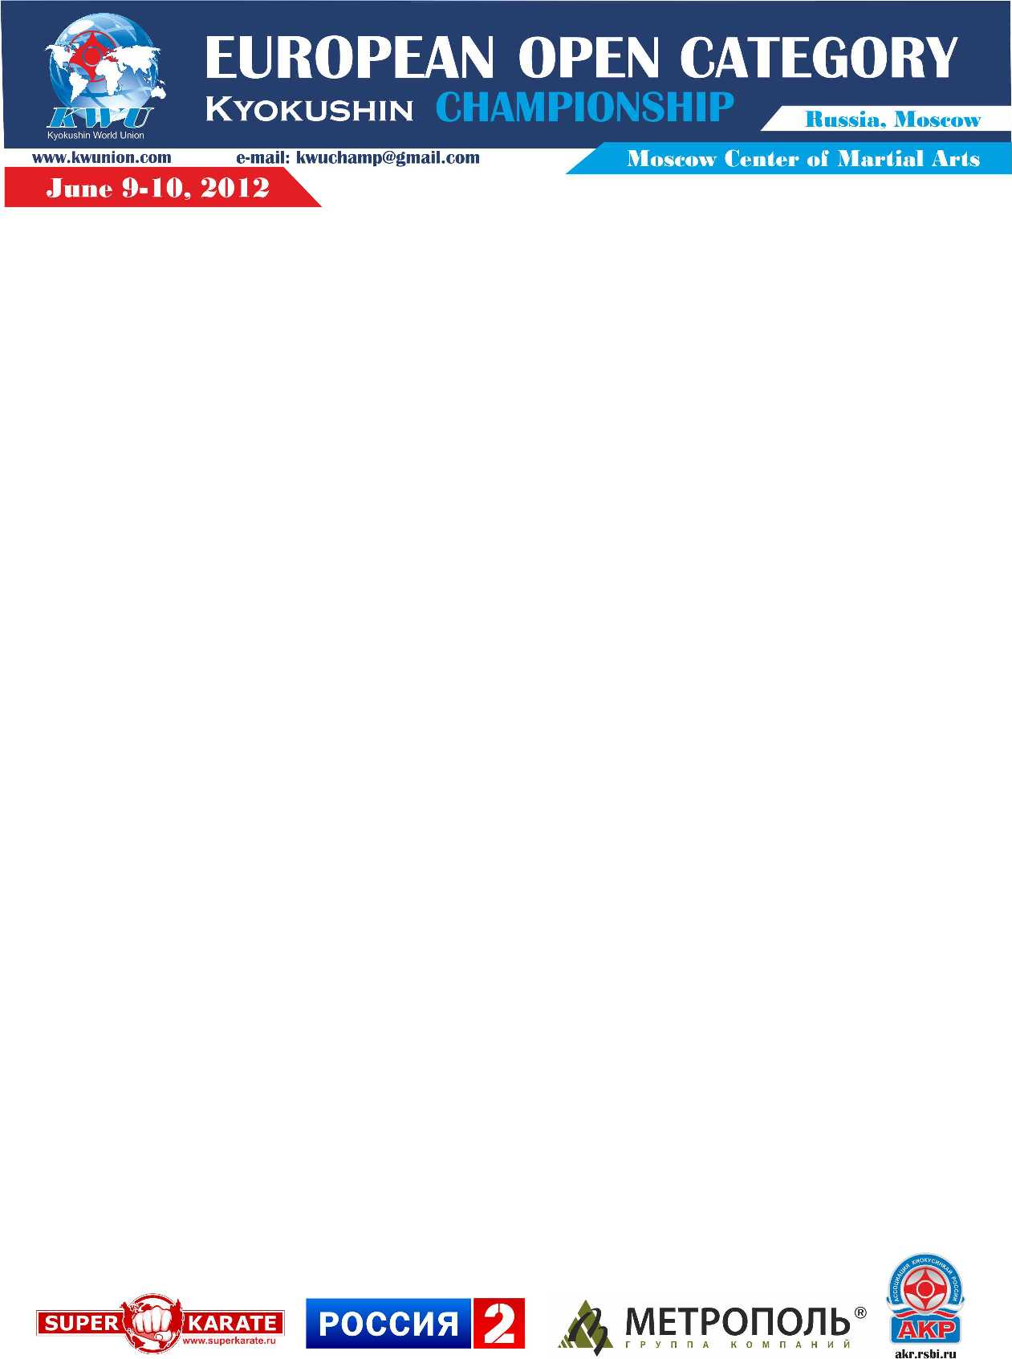

Attachment 4 – Application for accommodation

Application for the accommodation in the Hotel
of guests and participants
European Open Kyokushin Championship
men (kumite, tameshiwari)

from_____________________________________________________________________
__________________________________________________________________

Full name and telephone number of team’s representative ___________________________
__________________________________________________________________________

№ | Full name | Date of arrival | Date of departure | Time of arrival to the hotel
1
2

Signature and stamp _______________________________________________/L.S./

Attention! The nearest international airport from the hotel is Domodedovo (time of transfer consists 1 hour). We recommend you to take this information into consideration by purchasing the air tickets.

The hundred-per-cent payment is to be made till May 2, 2012.
Payment for staying in the hotel is not returned.

