Approved by
KWU General Secretary
Aleksandr Pichkunov
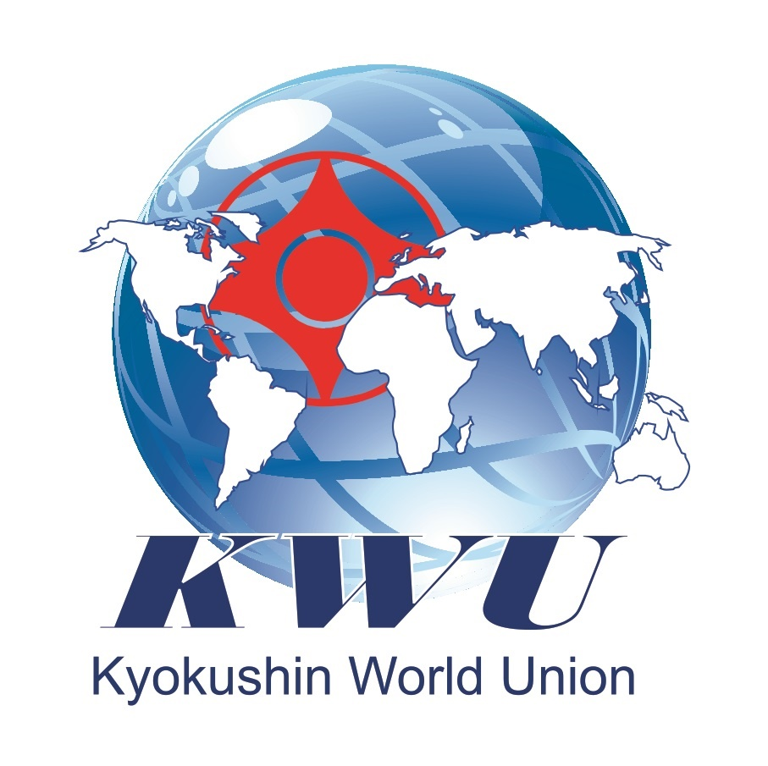
KWU Kyokushin World Cup for junior (14-15 years old), junior (15-16 years old) and cadets (18-21 years old) (kumite)

PROVISION

July 2nd 2019
BULGARIA, VARNA, KAMCHIA

6th KWU Kyokushin Open Youth World Championship (kumite)
Bulgaria, Varna, Kamchia, July 2nd 2019

Dates of keeping: July 2nd 2019
Conditions of access to participation:
Participants must take part in all activities of the International summer camp in Kamchia.
Juniors (14-15 years old) and juniors (16-17 years old) – Representatives of national federations selected at national championships with the invitation of all interested kyokushin groups in a given country, aged from 14 to 17 years with stylistic qualifications of at least 6 kyu and up to 3 fighters from a weight category from Organizations are allowed to participate in the competition.
Cadets (18-21 years old) - Representatives of national federations selected at national championships with the invitation of all interested kyokushin groups in a given country, aged from 18 to 21 years with stylistic qualifications of at least 6 kyu and up to 3 fighters from a weight category from Organizations are allowed to participate in the competition.

Timeline of events:
Date | Time | Event | Participants
June 30th | all day | arrival of participants | Judges  Leaders,  team representatives, fighters, coaches,  medics
July 1st | 10:00-12:00  14:00-17:00 | judicial seminar | judges
 | 10:00-19:00 | credentials commission  /by schedule/ | team representatives, fighters
July 2nd | 10:00 | Ceremonial opening | all
 | 10:15 | Beginning | all
 |  | Awarding ceremony | all

Financial conditions:
The entry fee from the participants of the competition is not charged.

KWU covers the following charges: accommodation, meals, transfer (Varna-Kamchia-Varna)

Applications for participation:

Deadline for applications: up to June 10th, 2019

Registration for submitting applications is available online on the website https://kwu.kumitetechnology.com/registration/ together with the application for participation in the XIII KWU International Summer Camp.

Contact number:
+359 88 9907857 Aleksandra Marinova English,
+359 88 4996666 Viliana Bozhilova Russian

General rules:

The competitions will be held by the rules of KWU, which are posted on the official web-site: www.kwunion.com

Judges:

The official list of judges will be approved by KWU at the end of the judicial seminar, which will be held on July 1st 2019 in Kamchia.
Those wishing to attend the seminar must apply for e-mail kwu_bulgaria@abv.bg with the indication "judging seminar" in the subject line.
Chief referee of the tournament - Ramil Gabbasov, 5th dan, Russia,
Deputy Chief referee of the tournament – Stoyan Dimov, 4th dan, Bulgaria

Awards:

Terms of summarizing
Sports competitions in kumite are held on the system with elimination after one defeat. Each weight category has two third places (no 3rd place battle will be).

Awarding of champions and prizewinners
Champions and prize-winners (1st-3rd places) are awarded with medals and diplomas as well as cups of corresponding grade.

Anti-doping control
Winners from 1st to 3rd places will go through doping test in accordance with the rules of the World Anti-Doping Agency (WADA).

Weight categories and composition of teams:
Composition of fighters and amount composition of a team:
- official team coach;
- fighters;
- team doctor (if any).

The quota for WKO Shinkyokushinkai
The competitors from WKO Shinkyokushinkai, who wish to participate in the KWU “World Cup” for juniors (14-15), juniors (16-17) and cadets (18-21) should contact their Branch Chiefs, who would inform about this request the WKO Shinkyokushinkai Headquarters.

№ | Age category (discipline) | Weight category
1 | boys (14-15 full years, kumite) | 45, 50, 55, 60, 65, 65+
2 | girls (14-15 full years, kumite) | 45, 50, 55, 60, 60+
3 | boys (16-17 full years, kumite) | 55, 60, 65, 70, 75, 75+
4 | girls (16-17 full years, kumite) | 50, 55, 60, 65, 65+
5 | cadets men (18-21 full years, kumite) | 60, 65, 70, 75, 80, 85, 85+
6 | cadets women (18-21 full years, kumite) | 50, 55, 60, 65, 65+

The age of the fighters is determined on the day of passing the credentials commission, that is July 1st 2019.

Obligations of fighters
During the credentials commission, leader of the team gives the original application (hard printed copy), and each fighter must have the following documents with him/her:
- Passport or birth certificate(for juvenile participants);
- allowance of sports medic to participate in competitions (in English);
- written application of a fighter – attachment №3;
- written permission to participate from both parents - attachment №3A;
- HIV antibodies test certificate (in English), issued not earlier than June 1st 2019;
- HBV antibodies test certificate (in English), issued not earlier than June 1st 2019;
- HCV antibodies test certificate (in English), issued not earlier than June 1st 2019;
- agreement of insurance from accident, valid at the time of competitions and list with names of insurance people with stamp(original, in English);

Protection:
Each fighter, allowed to participate in competitions, must have:
- white karategi and a belt, representing fighter’s qualification;
- individual groin shell: for boys– mandatory, for girls– voluntary;
- protectors for shin and insteps – mandatory for girls;
- knee pads, elbow pads – voluntary;
- handguards – mandatory;
- headgear– mandatory for all;
- chest protector of a standard type - for girls and women;
- gum shield (oral cavity protector), white colour – voluntary.
If there are brackets on teeth, gum shield is mandatory.
All protection items must have a mark of KWU.
ATTENTION! All protection items must be individual !

Schedule of fights:

Age category “boys/ girls” (14-15 years)
Boys (14-15 years)
Preliminary fights: 2 minutes + 2 minutes
Semi-final and final fights: 2 minutes + 2 minutes + weight check (weight difference 2.5 kg and more) + 1 minute

Girls (14-15 years)
Preliminary fights: 2 minutes + 2 minutes
Semi-final and final fights: 2 minutes + 2 minutes + weight check (weight difference 2.5 kg and more) + 1 minute

Age category “boys/ girls” (16-17 years)
Boys (16-17 years)
Preliminary fights: 2 minutes + 2 minutes
Semi-final and final fights: 2 minutes + 2 minutes + weight check (weight difference 2.5 kg and more) + 2 minutes

Girls (16-17 years)
Preliminary fights: 2 minutes + 2 minutes
Semi-final and final fights: 2 minutes + 2 minutes + weight check (weight difference 2.5 kg and more) + 2 minutes

Age category cadets (18-21 years)
Men (18-21 years)
Preliminary fights: 2 minutes + 2 minutes + 2 minutes
Semi-final and final fights: 3 minutes + 2 minutes + weight check (weight difference 2,5 kg and more) + 2 minutes
Women (18-21 years)
Preliminary fights: 2 minutes + 2 minutes + 2 minutes
Semi-final and final fights: 3 minutes + 2 minutes + weight check (weight difference 2,5 kg and more) + 2 minutes

Accommodation:
At the airport of arrival you will be met by representatives of KWU. Transfer to the hotel will be organized.
Attachment 3 – Fighter application

To the Supreme Judge of the championship

From_____________________________________________ (Full name)

Passport serial number____________________________

Date of issue, issuing authority________________________

_________________________________________________

APPLICATION FORM

I am requesting from you to let me, ________________________________________________
(Full name)

__________________________________________________________________________________
participate in KWU World Cup for juniors (14-15), juniors (16-17) and cadets (18-21) (kumite), which will take place on July 2nd 2019 in Bulgaria, Varna, Kamchia.
In case of my injury and the associated impacts, as well as other adverse consequences while taking part in the competition, including from the use of techniques permitted or not permitted by the rules of the competition, and / or while in the room where these competitions are held, or preparation for this competition is held, I will not claim against the Supreme Judge, the organizers of the tournament, coaches and owners of premises where competitions are held.
I am familiar with the rules of competition in Kyokushin, and I am completely aware that Kyokushin is a contact martial art, and I understand the possibility of injuries and other adverse effects received by me.

_________________________________________________ __________________
Full name in handwriting Signature

__________________
date

Attachment 3 A – from parents

DECLARATION
I……………………………………………………………………………………
( full names, telephone number, ID/PIN number and exact address on ID card),
as a legal representative of ……………………………………………………………………………………………………………. (full names, PIN/ID telephone number)

I DECLARE THAT,
I would like my child to be allowed to participate in category................ in …………… KWU World Cup for juniors (14-15), juniors (16-17) and cadets (18-21) (kumite), which will be held July 2nd 2019 in Bulgaria, Varna, Kamchia.
I give a clear approval that my child will participate in this tournament, in order of strengthening of health, increasing physical and sports culture.
In addition, I confirm that we are familiar with safety rules during the competitions and that my child will respect them and that he/ she has passed instructions.
I declare that my child is healthy, well prepared and there is no obstacles for his/her participation in the competition.
I am aware that in case of injuries or other adverse circumstances and consequences during and after KWU World Cup I will bear the cost of my child’s treatment and recovery, without having claims against the organizers of the competition, judges, coaches, trainers and other officials and NPO “Bulgarian Karate Kyokushin Federation” and KWU.
This declaration, I issue with clear conscious and without foreign interference, fully understanding that Kyokushin Karate is a contact sport with direct fighting and it is absolutely possible for my child to receive injures and adverse consequences of them for participation in the competition.
I confirm that my child do not use prohibited drugs and I give my agreement, if necessary, doping sample to be taken and medical check to be done.
1. DECLARANT:
2. DECLARANT:

