Guidelines for participants
of the 3rd KWU Kyokushin World Championship
among men and women in weight categories

December 9-10, 2017, Russia, Ekaterinburg

Palace of Sports (DIVS)

Russia, Ekaterinburg, Olimpiyskaya Embankment, 3 (Metro station “Dinamo”)

“TIME TO BE UNITED!”

Applications

Online registration is available on the official website of the World Championship www.kwu2017.com.
Access to registration will be provided after the request of Kyokushin group head in particular country, and after the confirmation of holding national qualifying championships. The requests must be sent to the e-mail address of organizing committee champ@kwu2017.com.
Deadline for registration: 01.10.2017

Information for coaches, medics and supporters

The above stated categories of the World Championship’s participants pay all their expenses on their own.
The applications for hotel booking, Visa support and buying of the tickets to the arena you should send to the e-mail - champ@kwu2017.com with phrase ‘Team of (your country)’ in the subject line, only after registration on the official website.

Deadline for the requests: not later than 01.10.2017.

Deadline for supporters’ applications – not later than 20.10.2017 (send it only to the e-mail champ@kwu2017.com with phrase ‘Supporters’ in the subject line).

Officials

The World Championship’s participants of this category pay for their trip to Ekaterinburg and back on their own.

In order to register the official person you should send a request to the e-mail -champ@kwu2017.com with phrase ‘Officials’ in the subject line and following information:

- Last and first names
- Date of birth
- Position at place of work
- Status in Kyokushin

Your application will be considered and after that, you will receive a reply.

Judges

The official list of the judges will be approved from the number of KWU accredited judges and will be published on the official website of the World Championship – www.kwu2017.com.

People, who wish to take part in the judicial seminar, which will be held on December 6-8, 2017 in Ekaterinburg, should send a request to the e-mail address champ@kwu2017.com with phrase ‘Judicial seminar’ in the subject line. All the financial expenses they pay themselves.

The Supreme Judge of the World Championship is Yuri Trutnev, the 5th Dan, Russia.
The Deputy Supreme Judge of the World Championship is Ramil Gabbasov, the 5th Dan, Russia.

Visa support

In order to get the visa support from KWU you should make the following steps:
1) To register the fighters and coaches on the official website of the championship.
2) To send the request to the official e-mail of the World Championship – champ@kwu2017.com with a list of the people, who would like to take part in the judicial seminar (with phrase «Judicial seminar»), and the list of the Officials (with phrase «Officials» in the subject line). To this letter you should obligatory attach the scan copies of their passports in a good quality (the scan of the page with a photo).
3) To purchase the package «Hotel + ticket to the arena» for the supporters, people, who would like to take part in the judicial seminar and officials by the request to the official e-mail of the World Championship.
4) To book the hotel rooms for coaches and medics by the request to the official e-mail of the World Championship.
5) To send to the e-mail - champ@kwu2017.com the list of people who wish to get the visa support with the phrase «Visas for (your country) ».

Recommendations concerning flights

All the categories of the World Championship’s participants pay for their trip to Ekaterinburg and back on their own.
The Organising Committee recommends buying the unified ticket from the city, where you live to Ekaterinburg because in that case it:
- Significantly lowers the risk of the late arrival,
- Significantly saves your money.
For example: the tickets Berlin-Ekaterinburg-Berlin (with change of plane in Moscow) will cost 270 euro, meanwhile Berlin-Moscow-Berlin – 200 euro, and Moscow-Ekaterinburg-Moscow will cost you 150 euro more.

Accommodation
The accredited hotel of the 3rd KWU Kyokushin World Championship – ‘Atrium Palace Hotel’.
Ekaterinburg, Kuybysheva Street, 44

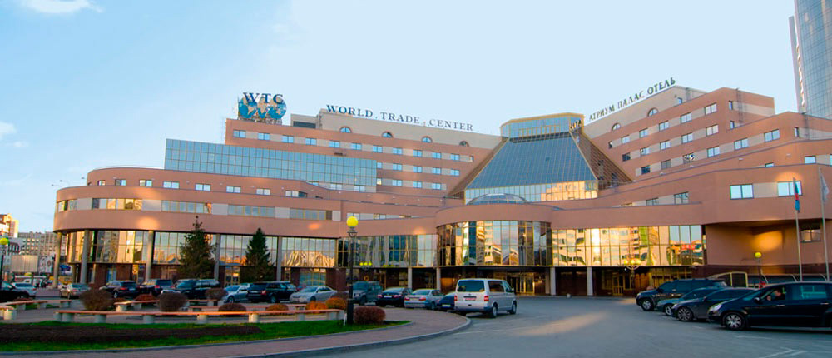

All categories of the participants will be accommodated in the 3 hotels, which are located on the same square with "Atrium Palace Hotel".
Hotel booking should be made only by the request to the e-mail - champ@kwu2017.com with phrase «Hotels» in the subject line.
KWU will book the rooms for the registered fighters and selected judges on its own. There is no need in sending separate application for this purpose.

Location
Palace of Sports (DIVS),
620027, Russia, Ekaterinburg, Olimpiyskaya Embankment, 3 (Metro station “Dinamo”)
http://divsport.ru/

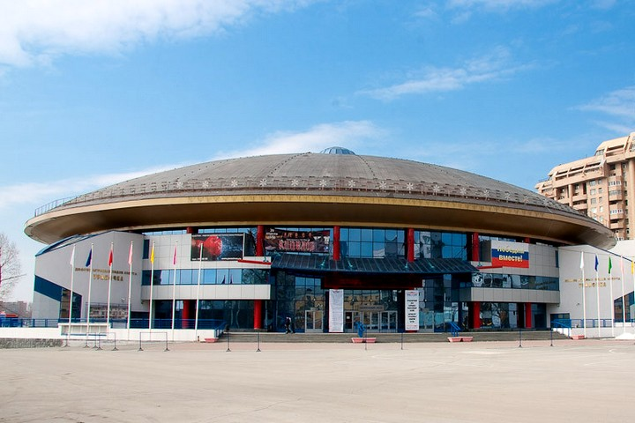
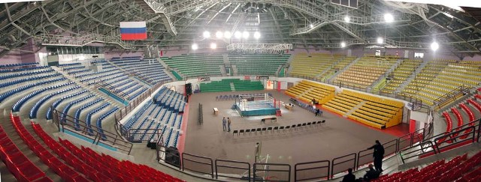

Entrance to the arena

The fighters will be able to come to the warming-up zone by their badges.
On the second day of the competition for those who will not pass to the finals will be given the special spectators’ seats.

Officials, who will be approved by KWU, will get the badges, which will allow them to take the places in the special spectators’ sector.

Coaches and medics will be allowed to come to the warming-up zone by their badges.
On the second day of the competition, the coaches and medics will be able to get to the warming-up zone only if the fighter, whom they accompany, fights in the final bouts of the World Championship.
During the registration process, a coach should specify whom of the fighters he plans to accompany to the tatami, because only the coach, who wrote the name of the particular fighter in the registration form, is allowed to accompany him.

Supporters should buy the tickets to the arena’s seats by sending the request to the e-mail -champ@kwu2017.com with phrase «Ticket to the arena» in the subject line.

Official information:

Weight categories
Men (18 years and older, kumite): 60, 65, 70, 75, 80, 85, 90, 95, 95+ kg.
Women (18 years and older, kumite): 50, 55, 60, 65, 70, 70+ kg.
The fighter’s age is determined as at the day of going through the credentials commission, which is December 8, 2017.

Conditions of participation and number of participants from each country
One fighter from a country is allowed in each weight category.

Representatives of national federations, who have passed national qualifying championships with calling of all interested groups of Kyokushin in a particular country at age of 18 years old and above with a style qualification not less than 4th kyu are allowed to participate in the World Championship.
Time and place of holding national qualifying championships are determined jointly by representatives of international organisations, listed in the “Members” section on www.kwunion.com.
The results of national qualifying championships should be sent to the KWU office e-mail address - champ@kwu2017.com.

Participation of fighters from WKO Shinkyokushinkai
The fighters from WKO Shinkyokushinkai, who wish to participate in the 3rd KWU Kyokushin World Championship, should contact their Branch Chiefs, who would inform about this request the WKO Shinkyokushinkai Headquarters.

General rules
The competitions will be held by the rules of KWU, which are published on the official website: www.kwunion.com

Conditions of summarizing of the results
The championship is a single-elimination tournament with elimination of the loosing fighter after one defeat. There will be two 3rd place winners in each weight category (no bouts for the third place).

Timeline of events

05.12.2017 (Tuesday)  Arrival of judges  06.12.2017 (Wednesday)  14:00 – 20:00 – Judging seminar  07.12.2017 (Thursday)  Arrival of fighters, officials, trainers and country representatives  10:00 – 14:00 – Judging seminar  08.12.2017 (Friday)  10:00 – 18:00 – Credentials Committee  10:00 – 14:00 – Judging seminar  18:00 – 19:00 – Common meeting of fighters, judges, organizers and representatives | 09.12.2017 (Saturday)  10:00 - Preliminary fights (up to finals)  10.12.2017 (Sunday)  17:00 – Opening ceremony  17:30 – finals  22:00 – Sayonara Party  11.12.2017 (Monday)  Departure from the hotel (before 12 am) and departure

Financial conditions

The entry fee from fighters will not be charged.

KWU covers the following charges:
- accommodation for approved KWU judges in twin rooms of the accredited hotel (Full Board) – December, 5 – 11;
- accommodation for fighters in twin rooms of the accredited hotel (Half Board) – December, 7 – 11;
- lunches for fighters during the days of the tournament – December 9-10, 2017.
- transfer for fighters and for the approved KWU judges from the airport of Ekaterinburg to the hotel and back.

Anti-doping control

The prize-winners from the 1st to the 3rd places will have to go through the doping test in accordance with the rules of the World Anti-Doping Agency (WADA).

Organizing committee – champ@kwu2017.com, +7-495-640-23-63

