OFFICIAL INFORMATION LETTER.
3rd KWU Kyokushin World Championship
among men and women in weight categories

December 9-10, 2017, Russia, Ekaterinburg

Palace of Sports (DIVS)

Russia, Ekaterinburg, Olimpiyskaya Embankment, 3 (Metro station “Dinamo”)

“TIME TO BE UNITED!”

Weight categories
Men (18 years and older, kumite): 60, 65, 70, 75, 80, 85, 90, 95, 95+ kg.
Women (18 years and older, kumite): 50, 55, 60, 65, 70, 70+ kg.
The fighter’s age is determined as at the day of going through the credentials commission, which is December 8, 2017.

Conditions of participation and number of participants from each country
One fighter from a country is allowed in each weight category.

Representatives of national federations, who have passed national qualifying championships with calling of all interested groups of Kyokushin in a particular country at age of 18 years old and above with a style qualification not less than 4th kyu are allowed to participate in the World Championship.
Time and place of holding national qualifying championships are determined jointly by representatives of international organisations, listed in the “Members” section on www.kwunion.com.
The results of national qualifying championships should be sent to the KWU office e-mail address champ@kwu2017.com.

Participation of fighters from WKO Shinkyokushinkai
The fighters from WKO Shinkyokushinkai, who wish to participate in the 3rd KWU Kyokushin World Championship, should contact their Branch Chiefs, who would inform about this request the WKO Shinkyokushinkai Headquarters.

Judges
The judicial committee of KWU will determine the quota of judges individually for each country from the number of:
- the judges, accredited by KWU;
- the judges, who will pass the judicial seminars, which will be held on December 6-8, 2017 in Ekaterinburg.

The supreme judge of the World Championship is Shihan Yuri Trutnev, the 5th Dan, Russia.

General rules
The competitions will be held by the rules of KWU, which are posted on the official website: www.kwunion.com

Conditions of summarizing of the results
The championship is a single-elimination tournament with elimination of the loosing fighter after one defeat. There will be two 3rd place winners in each weight category (no bouts for the third place).

Timeline of events

05.12.2017 (Tuesday)  Arrival of judges  06.12.2017 (Wednesday)  14:00 – 20:00 – Judging seminar  07.12.2017 (Thursday)  Arrival of fighterss, officials, trainers and country representatives  10:00 – 14:00 – Judging seminar  08.12.2017 (Friday)  10:00 – 18:00 – Credentials commission  10:00 – 14:00 – Judging seminar  18:00 – 19:00 – Common meeting of fighters, judges, organizers and representatives | 09.12.2017 (Saturday)  10:00 - Preliminary fights (up to finals)  10.12.2017 (Sunday)  17:00 – Opening ceremony  17:30 – finals  22:00 – Sayonara Party  11.12.2017 (Monday)  Departure from the hotel (before 12 am) and departure

Location
Palace of Sports (DIVS),
620027, Russia, Ekaterinburg, Olimpiyskaya Embankment, 3 (Metro station “Dinamo”)
http://divsport.ru/

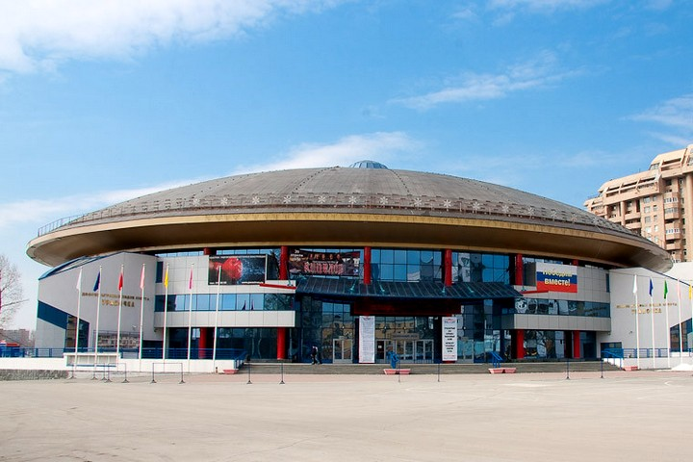
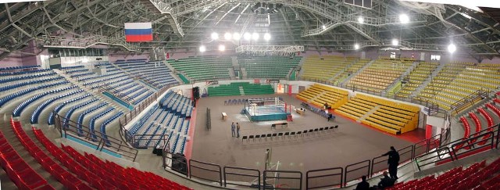

Accommodation
The official hotel of the 3rd KWU Kyokushin World Championship – ‘Marins Park Hotel’.
Ekaterinburg, Chelyuskintsev Street, 106.
http://sv-hotel.ru

Hotel booking and reservations will be available on the official website of the Championship (kwu2017.com) in the category "Registration" since August 15, 2017.
Deadline for hotel booking and final confirmation: not later than 01.10.2017.

Financial conditions

The entry fee from fighters will not be charged.

KWU covers the following charges:
- accommodation for judges in twin rooms of the official hotel – December, 5 - 11;
- meals for judges: December, 5th - dinner, December, 6 - 10 – breakfast, lunch, dinner;
December, 11th – only breakfast.
- accommodation for fighters in the official hotel – December, 7 – 11;
- meals for fighters: December, 7th - dinner, December, 8 – breakfast, dinner; December, 9 - 10 – breakfast, lunch, dinner; December, 11th – only breakfast.
- transfer for fighters from the airport to the hotel and back.

Anti-doping control

The prize-winners from the 1st to the 3rd places will have to go through the doping test in accordance with the rules of the World Anti-Doping Agency (WADA).

Applications

Online registration will be available on the official website of the Championship www.kwu2017.com since August 1st, 2017.
Access to registration will be provided after the request of Kyokushin group head in particular country, and after the confirmation of holding national qualifying championships. The requests must be sent to the e-mail address of organizing committee champ@kwu2017.com.
Deadline for registration: 01.10.2017

Organizing committee – champ@kwu2017.com, +7-495-640-23-63

General Secretary of KWU

Sergey Suvorov

